Industry-Academia Partnership and Pathways (IAPP)

Grant agreement no: 2013-612326

**Work Package 2**

**D2.1 Evaluation of sensory characteristics of processed vegetables across age groups and countries**

**Consumer perception (product and sensory analysis)**

Authors:

University of Florence -Italy: Caterina Dinnella, Camilla Masi, Danny Cliceri, Isabella La Viola & Erminio Monteleone

Bonduelle - France: Morizet David & Laurence Depezay

**ACKNOWLEDGEMENTS**

The authors gratefully acknowledge the European Com munity’s financial support under the

Seventh Framework Programme for Support for training and career development of researchers (Marie Curie).

**DISCLAIMER**

The views expressed in this publication are the sole responsibility of the author(s) and do not necessarily reflect the views of the European Commission. Neither the European Commission nor any person acting on behalf of the Commission is responsible for the use that might be made of the information. The information in this document is provided as is and no guarantee or warranty is given that the information is fit for any particular purpose. The user thereof uses the information at its sole risk and liability.

**VEGGIEAT PROJECT TEAM**

|  |  |  |
| --- | --- | --- |
| **Steering Committee Members** | **Title** | **Institution** |
| Professor F. J. Armando Pérez-Cueto, PhD | Associate Professor of Public Health Nutrition | **UNIVERSITY OF COPENHAGEN** |
| Mrs Laurence Depezay |  | **BONDUELLE SA**  Pôle Produits R&D, Fondation Louis Bonduelle  Tel: +33 3 20 43 63 71  E-mail: [ldepezay@bonduelle.com](mailto:ldepezay@bonduelle.com)  Web: [www.bonduelle.com](http://www.bonduelle.com) |
| Professor Heather Hartwell, PhD | Professor of Foodservice and Applied Nutrition | **BOURNEMOUTH UNIVERSITY**  Foodservice and Applied Nutrition Research Group and Health and Wellbeing, School of Tourism, Dorset House, Fern Barrow, Poole, Dorset, BH12 5BB, UK  Tel: +44 (0)1202 961712  Mob: +44 07738 755135  E-mail: [hhartwell@bournemouth.ac.uk](mailto:hhartwell@bournemouth.ac.uk)  Web: [www.bournemouth.ac.uk](http://www.bournemouth.ac.uk) |
| Dr Agnès Giboreau, PhD, - H.D.R. | Research Director | **INSTITUTE PAUL BOCUSE**  Centre De Recherche, Chateau Du Vivier, BP25- 69131 Ecully Cedex, France  Tel: +33 (0)4 72 18 09 81  Mob: +33 (0)6 19 80 67 11  E-mail: [agnes.giboreau@institutpaulbocuse.com](mailto:agnes.giboreau@institutpaulbocuse.com)  Web: [www.institutpaulbocuse.com](http://www.institutpaulbocuse.com) |
| Professor Erminio Monteleone | Sensory Food Science Professor and Head of the Sensory Unit at GESAAF | **UNIVERSITY OF FIRENZE**  Sensory Unit at GESAAF, Via Donizetti 6, Firenze, Italy  Tel: + 39 055 275 5505  Mob: +39 315 45 96 458  E-mail: [erminio.monteleone@unifi.it](mailto:erminio.monteleone@unifi.it)  Web: <http://www.scienzesensoriali.it> |

|  |  |  |
| --- | --- | --- |
| **Advisory Committee Members** | **Title** | **Institution** |
| Professor Bent Egberg Mikklesen, PhD | AAU –MENU Research Coordinator, Chair of the group of experts (GREX) for the Voluntary EU School Fruit Scheme (SFS), member of international scientific group for the Sapere method | **AALBORG UNIVERSITY**  Meal Science and Public Health Nutrition Research Group, Department of Development and Planning, A. C. Meyers Vænge 15, 2450 Copenhagen SV, Denmark  Tel: +45 99 40 25 56  Mob: + 45 25 38 43 66  E-mail: [bemi@plan.aau.dk](mailto:bemi@plan.aau.dk)  Web: <http://personprofil.aau.dk/119690?lang=en> |
| Professor John S. A. Edwards, PhD | Professor of Foodservice | **BOURNEMOUTH UNIVERSITY**  Foodservice and Applied Nutrition Research Group, School of Tourism, Dorset House, Fern Barrow, Poole, Dorset, BH12 5BB, UK  Tel: +44 (0)1202 691637  Mob: +44 (0) 77 88 1969 00  E-mail: [edwardsj@bournemouth.ac.uk](mailto:edwardsj@bournemouth.ac.uk) or [john.edwards@live.co.uk](mailto:john.edwards@live.co.uk)  Web: [www.bournemouth.ac.uk](http://www.bournemouth.ac.uk) |
| Dr Gitte Laub Hansen, PhD | Executive Project Manager | **DANISH CANCER SOCIETY**  Prevention and Documentation * , Diet and Physical Activity, Strandboulevarden 49, DK-2100, Copenhagen, Denmark  Tel: +45 3525 7547  Mob: +45 3065 1014  E-mail: [glh@cancer.dk](mailto:glh@cancer.dk)  Web: [www.cancer.dk](http://www.cancer.dk)  *\* please note that the department name will change to ‘Prevention and Information’ as of 1 Apr 14* |
| Dr Lucas P. J. J. Noldus, PhD | Managing Director | **NOLDUS INFORMATION TECHNOLOGY BV**  Nieuwe Kanaal 5, P.O. Box 268, 6700 AG Wageningen, The Netherlands  Tel: +31-317-473300  Mob: +31-6-53425199  E-mail: lucas.noldus@noldus.nl  Web: [www.noldus.com](http://www.noldus.com) |

**Executive Summary**

**Introduction**

Vegetables are one of the most difficult categories of food to introduce into a diet especially within a foodservice operation. The product attributes, the individual characteristics of the consumer and the eating environment all play a key role in food-related decisions. The aim of VeggiEAT is to develop an EU platform for predictive modeling of processed vegetable intake that takes into account individual characteristics (acceptability, intake level, age groups) as well as environmental cues (choice architecture and institutional setting). This aim will be achieved through the development of consumer-oriented products (sensory evaluations); the development of recipes for use by institutional food providers (restaurants, canteens, etc.); and the benchmarking of choice architecture facilitating the consumption of vegetables.

The objective of **WP2** was to evaluate the sensory characteristics of the vegetables that would influence their choice by different age groups. The specific objectives were from a methodological perspective: *To optimize the free sorting task in regard to the kind of products (i.e. vegetables) and to the kind of consumers (i.e. age / nationality)* and from a knowledge perspective: *To better understand consumer perception of the product sensory variations according to their characteristics (i.e. age, gender, nationality) leading to operational output: Key information/ recommendations for product range rationalisation and design.* Furthermore, this WP addressed the following Industry challenges: *Sensory product characterisation; Perception of sensory variation and acceptability according to consumer characteristics; Optimisation of sensory and consumer tests according to subject characteristics and suitable for the specific vegetable products (from a technical perspective).*

Research components of WP2 are: **Task 2.1 (product characterisation)**: Consists of the sensory characterisation of vegetables by means of descriptive methods. **Task 2.2 (consumer test design)**: Optimisation of several parameters of the free sorting task method. **Task 2.3 (consumer tests)**: Evaluation of sensory variation discrimination according to consumer background (age, nationality) applying a free sorting test and collecting liking and questionnaire responses.

Methodologies and approaches in planning and conducting research activities in relation to relative aims are introduced for each task.

**Methodology**

*Products*

Canned peas and sweetcorn were selected among the large diversity of food in the vegetable category considering their large availability on the market, their different history and use modalities in European culinary tradition. Ten pea (codes: A,B,D,E,F,J,L,O,P,Q) and eight sweet corn (codes: H,R,S,T,U,V,W,Z) samples were selected in order to cover as much as possible the diversity available for each vegetable.

*Subjects*

Subjects were recruited in school and elderly in care institutions and/or leisure facilities in Copenhagen (Denmark - DK), Lille (France - FR), Florence (Italy, IT) and Bournemouth (United Kingdom, UK). Ethical approval was sought and granted through standard university procedures in all countries. In total 497 adolescents (mean age 14) and 498 elderly subjects (mean age 68.75) were recruited in the four countries.

*Product characterization*

The sensory profile of tested samples was obtained by means of Descriptive Analysis *(*DA). Two panels of 12 subjects participated in the analysis of peas and corn, respectively. Twenty-six and twenty attributes describing appearance, aroma (odour by nose), flavour and mouthfeel characteristics were defined for peas and for sweetcorn, respectively. For each product, samples were evaluated in triplicate. Intensities were rated on a 9-point category scale.

Product were also instrumentally characterized.

*Consumer test: Experimental procedure*

Peas and sweetcorn samples were evaluated in independent sessions. Subjects participated in one or two sessions. The experiment took place in common room at schools or at elderly centers. The experimental procedure consisted in three steps: 1. Liking task, 2. Collection of Questionnaire data; 3. Sorting task.

*- Liking task:* Participants were provided with individual trays with coded pea or sweetcorn samples. Subjects were asked to look at the appearance, smell and taste a tea-spoon of each sample, then they were asked to rate their liking on a 9-point category scale.

*- Questionnaire*: After completing the liking task, subjects filled in a questionnaire consisting of 3 sections: 1. socio-demographic background (age, gender and education); 2. stated liking for a list of eleven vegetables widespread in Europe on a 9-point category scale (1: dislike extremely; 9: extremely like); 3. familiarity with the same vegetable list on a 5-point category scale.

*- Sorting task:* In the last part of the session subjects were provided with a new tray with eleven or nine three-digit coded pea or sweetcorn samples. Subjects were asked to observe, smell and taste samples and then to group them according to their similarities, the number of groups formed should be no less than 2. Subjects were asked to take note on individual ballots of their own criteria used to group samples.

**Results and conclusions**

The activities related to Task 2.1 in WP2 provided a detailed sensory description of canned peas and sweetcorn samples commonly available in the market. Main sensory differences among samples were identified for both products. This information is essential for achieving two aims: exploring sensory characteristics driving elderly and adolescents liking across Europe and studying the relationship between sensory and instrumental data to improve the quality control of these products. In the present study DA provided: 1) a validated sensory profile of each sample, 2) the relative importance of appearance, flavour and texture attributes in discriminating products by means of perceptual maps. The study of the relationship between sensory properties and instrumental measurements was then possible. The projection of Firmness and NMR data onto the obtained sensory spaces resulted in a good evidences of the potential use of these measurements to predict relevant sensory differences among samples.

Results from activities related to Task 2.2 showed that the minimum number of consumers required for free sorting studies seems higher than the one recommended in previous works in which product configurations were considered stable when working with more than 25-30 consumers. For both adolescent and elderly, a minimum number of 50 subjects is fair when working with familiar canned vegetables such as peas. A larger panel size (70 or more) is required when working with less familiar products such as sweetcorn. Our results showed that product knowledge and in particular one of its components (respondent familiarity with the product under investigation) is a factor that should always be considered to define the panel size to perform a sorting task.

Results from the consumer study (Task 2.3) showed that both elderly and adolescents sort vegetable samples in relation to sensory properties that are relevant for their hedonic judgment about the product. High correlations values were found in comparing sorting configurations from each country and each age group with the perceptual maps from descriptive analysis for both peas and sweetcorn. Sample grouping was consistent across countries with minor differences that seem to be related to the familiarity with the product. When sorting task is conducted with familiar products (like peas) differences among countries and age groups tend to be minimal. Both elderly and adolescents showed no difficulties in eliciting terms (sensory and hedonic) that describe the characteristics of the groups they formed in the sorting task. This means that this approach is an effective method to explore vegetable perception in both age groups and obtain information about sensory and hedonic dimensions driving product discrimination. When applied in cross country and across age studies, the free sorting task overcomes limitations of other approaches (e.g. rating methods and questionnaires) in which results might be strongly affected by cultural differences in the expression of responses (e.g. differences in the use of rating scale across countries and ages).

Lists of terms of perceived properties of peas and sweet corn samples were obtained for the two age groups from all countries. This output is relevant when the interest is focused consumer language to better understand sensory barriers to increase vegetable consumption. Relative differences were found in the number and nature of the terms used to describe sample groups formed during the sorting task across countries and ages. Appearance seems to be less relevant for elderly than for adolescents in discriminating samples. Old respondents tend to focus their attention more on texture and hedonic terms. The oppositions sweet vs bitter; richness in flavour vs lack of taste, always associated with hedonic terms, drove product discrimination independently from countries and age groups. The study of the correlation between the occurrences of consumer terms and intensity data from descriptive analysis allowed to “translate” consumer language in sensory characteristics. For instance, the term “bad taste” was found to be associated with the sensory attributes “acrid” or “metallic”. Similarly the negative hedonic expression “bad texture” was found to be associate with the sensory attribute “softness” in sweetcorn samples and “hardness” in pea samples. This information is of great importance to set up proper quality control in food companies.

Task 2.3 also explored and compared the actual liking of adolescents and elderly across the four European countries. Results confirm the effect of familiarity on stated and actual liking for vegetables. The more familiar respondents are with a specific food, the more they will like and prefer it. In the present study, the more familiar the respondents were with a vegetable the higher were the differences in liking among the presented samples. For instance, French and Italian adolescents were more familiar with and expressed a higher stated liking for peas than for sweet corn. An opposite trend was observed for Danish and British adolescents. As consequence, British and Danish teens scored their liking for sweetcorn samples significantly higher than for pea samples.

The analysis of individual differences in liking allowed to understand the role of flavour and texture in canned peas and sweetcorn acceptance from actual tasting experimental sets. The within-product approach used in this study, highlighted that, independently from familiarity and stated liking, main drivers of actual liking and disliking are the same across countries and ages. Sweetness, in opposition to bitterness and sourness, confirmed to drive actual liking for vegetables. The influence of saltiness on liking was positive for peas but negative for sweet corn. Similarly, softness was positively related to liking for peas and negatively for sweet corn. Richness in flavour and in colour was strongly correlated to liking for both peas and sweetcorn. This information should be considered by food producers and the catering sector when promoting the consumption of peas and sweetcorn among adolescents in Europe. In relation to VeggiEAT research project the results of WP2 feeds WP3 where recipe development is underway led by the Institute Paul Bocuse Research Centre.

**Introduction**

Vegetables are one of the most difficult categories of food to introduce into a diet especially within a foodservice operation. The product attributes, the individual characteristics of the consumer and the eating environment all play a key role in food-related decisions. The aim of VeggiEAT is to develop an EU platform for predictive modelling of processed vegetable intake that considers individual characteristics (acceptability, intake level, age groups) as well as environmental cues (choice architecture and institutional setting). This aim will be achieved through the development of consumer-oriented products (sensory evaluations); the development of recipes for use by institutional food providers (restaurants, canteens, etc.); and the benchmarking of choice architecture facilitating the consumption of vegetables.

Previous consumer studies have given some indication of attitude to and preference for vegetable intake but there has been limited attention given to contextual factors such as sensory variation which would aid industry response. For this reason, among the WPs’ of the project, WP2 was designed to explore, in a EU cross-country study, the relevance of relative sensory differences among a set of samples in determining the acceptance of a vegetable product in adolescents and elderly.

Common approaches to gain information on determinants of vegetable acceptance are based on between-vegetable comparisons based on interview and questionnaire data collection. (see Jekins and Horner, 2005; Krolner et al, 2011; Heath et al., 2011 for reviews). Results from these kinds of studies agree on socio-demographic and cultural factors as well as individual traits playing a role in vegetable acceptance. However, they depict a more complex frame of sensory determinants of vegetable acceptance. In fact, sensory properties deduced to be liked in a vegetable, can be irrelevant or disliked in one other kind of vegetable. Thus, it appears difficult to understand the role of flavour and texture in vegetable acceptance without collecting liking and sensory data from actual tasting experimental sets. Whereas it has been broadly developed for other food categories, the within-vegetable comparison is a quite new approach, based on the evaluation of the same type of vegetable with varied sensory properties.

In VeggiEAT WP2, differences and similarities in liking for pea and sweet corn canned samples across the four European countries were explored in adolescents and elderly. These vegetables were selected considering their large availability on the market, their different history and use modalities in European culinary tradition. In fact, peas are consumed by several centuries (Pelt, 1993) and represent the main component of several dishes in culinary tradition of the countries participating in the study. Sweetcorn has been introduced in Europe in the second part of the 20th century, it is consumed in a less variety of uses and is mainly considered as secondary ingredient (eg. mainly used as salad topping in FR and IT). Thus, differences in familiarity and liking between these two vegetables were expected possibly influencing the hedonic value of their sensory properties. Different varieties of canned peas and canned sweetcorn widely varying for their sensory properties were considered in the project. It is worth to consider that, in general processed vegetables, including, canned and frozen varieties provide a convenient way to help promote vegetable intake as they have a longer shelf life than their fresh counterpart, are available out of season and are easy to use in commercial meal preparation and dish development. This latter aspect enables vegetables to be incorporated into production schedules where labour is limited or unskilled or equipment is not available.

The objective of **WP2** was to evaluate the sensory characteristics of the vegetables that would influence its choice by different age groups. The specific objectives were from a methodological perspective *to optimize the free sorting task in regards to the kind of products (i.e. vegetables) and to the kind of consumers (i.e. age / nationality)* and from a knowledge perspective *to better understand consumer perception of the product sensory variations according to their characteristics (i.e. age, gender, nationality) leading to operational output: Key information/ recommendations for product range rationalisation and design.* Furthermore, this WP addressed the following Industry challenges: *Sensory product characterisation; Perception of sensory variation and acceptability according to consumer characteristics; Optimisation of sensory and consumer tests according to subject characteristics and suitable for the specific vegetable products (from a technical perspective).*

Research components of WP2 are: **Task 2.1 (product characterisation)**: Consists of the sensory characterisation of vegetables by means of descriptive methods. **Task 2.2 (consumer test design)**: Optimisation of several parameters of the free sorting task method. **Task 2.3 (consumer tests)**: Evaluation of sensory variation discrimination according to consumer background (age, nationality) applying a free sorting test and collecting liking and questionnaire responses.

Methodologies and approaches in planning and conducting research activities in relation to relative aims are introduced for each task:

**Task 2.1 (product characterisation)**: *Sensory characterisation of vegetables by means of descriptive methods*.

Descriptive analysis is a term generally used to describe a sensory method by which identification, quantification and description of sensory attributes (the so-called sensory profile) of food by human subjects are obtained (Piggott et al., 1998). The most widely used profile technique is generally named “conventional descriptive analysis” (see ISO standard norm 11035, 1994; Lawless and Heymann, 1998, p. 362). Conventional descriptive analysis (DA) has been widely used to provide qualitative as well as quantitative measures of food and beverages properties. It is based on independent judgments of panelists (trained subjects) and statistical testing, thus it can provide a picture of how products differ among themselves, implying a comparison among products. Several products are assessed together, and the descriptive profile of a single product is both placed in and compared with the context of other products (Murray et al., 2001). It is a multi-product test that uses a limited number of subjects (10-15 trained assessors). It requires a language development process. This is a consensus building process aimed at defining the attributes the panel utilizes to represent their perceptions. Subjects familiarize with the product space and generate attributes that describe the differences among products. During language development, subjects practice scoring products to familiarize with products and the scale rating system. Panel performance is evaluated at the end of the training period.

The data are averaged across the panel and it implies statistical evaluation of results.

Data from DA can be graphically represented by spider or bar plots that describe for each product the mean values of each sensory attribute and thus the profile that characterises each sample under investigation. However, when a set of samples selected to represent the sensory variability of a product (eg. canned sweetcorn or pea samples) has to be characterized, differences and similarities among products analysed by means descriptive methods can be interpreted using perceptual maps.

A perceptual map is defined as a “pictorial representation that capture the relationships among a set of products” (Lawless and Heymann, 1998) and it is obtained by submitting sensory data to a variety of multivariate statistical techniques. These techniques can extract from complex data (a matrix with many products and variables) the most important information (how different are the products from each other and how much each variable contributes to the difference among samples) and present the results in a simplified picture or map in two or three dimensions that can be easily understood. It shows the differences and similarities among a set of samples: products that are similar to one other are positioned close to one other. Furthermore, vectors corresponding to important attributes are projected to interpret directions through the space.

Because of its characteristics, perceptual mapping is very attractive but also effective. It is easy to understand that perceptual maps can be useful for many purposes in product development. They can be used in an early phase of an investigation as an explorative tool to provide an overview, but they can also be used to generate hypotheses and ideas for further experimentations (Naes, Brockhoff and Tomic, 2010) as well as to confirm previous hypotheses. Perceptual mapping is a necessary step to effectively relate sensory properties to both consumer hedonic responses by means preference mapping and to chemo-physics characteristics of samples in multi-product studies.

Principal Component Analysis (PCA) is a very well known multivariate statistical method and probably the most applied approach to obtain a perceptual map from descriptive data (see Martens and Martens, 2001). For the purpose, PCA models are computed on the product-by-attribute matrix, after having averaged out both replicates and assessors. The method is based on the computation of the most interesting directions of variability, called principal components. The main results are graphically presented in the score plot, which describes the relations between the products, and the loading plot, which describes the relations between the sensory attributes and the principal components. Martens and Martens (2001) proposed a modification of the loading plot that can facilitate the interpretation of the importance of variables in discriminating between products: the correlation loading plot. This is a two-dimensional scatter plot of correlations between the principal components and the variables themselves. The advantage of this plot is that the researcher can directly obtain information about how much each variable is explained by each component. Moreover, the correlation plot gives the possibility of drawing circles in the plot corresponding to various degrees of explained variances. Typically, a circle for 100% explained variance and for 50% explained variance, for the two components are drawn.

The graphical interpretation of the plots follows simple rules (Naes, Brockhoff and Tomic, 2010):

- products which are close to each other have similar overall properties and samples which are far apart are very different;

- attributes which are close are strongly and positively correlated, while those on opposite sides of the origin have negative correlation;

- products to the left of the score plot are characterised by attributes to the left in the loading plot; products to the top of the score plot are characterised by attributes to the top in the loading plot, etc;

- the higher the explained variance, the more valid is the information obtained from the perceptual map.

In VeggiEAT Task 2.1, the sensory characterization of the selected canned vegetables derives from the application of the conventional descriptive analysis and the computation of relative perceptual maps by means of PCA.

**Task 2.2 (consumer test design)**: *Optimisation of parameters of the free sorting task method*.

The free sorting task (FST) originated in Psychology, is a method frequently applied to obtain representations of the differences amongst products. It was used for the first time to explore sensory differences among food products by Lawless and co-workers (1995). Because of its immediateness and ease of application, it is assumed to be useful tools in product development in order to understand how consumers perceive food products (Buck, 2007; Varela, 2012; Valentin, 2012).

In the sorting method, subjects are asked to sort items into two or more groups: items that have something in common are placed in the same group, whereas items that differ from one another should be placed in different groups. All products are presented simultaneously and randomly displayed on a table with a different order per assessor. Respondents are asked first to look at, smell and taste all the products and then to sort them in mutually exclusive groups based on product-perceived similarities (Valentin, 2012). Respondents can use the criteria they want to perform their sorts, and they are free to make as many groups as they want and to put as many products as they want in each group. After completing their sorting task, subjects can be asked to give a few words or descriptors that provided the criteria on which they had based their sorting. This information is used to interpret the differences among products. In this method, similarity is a group-derived estimate; in fact, similarity is inferred from the number of times two items are sorted into the same group across a panel of participants. Data from the sorting task for each sample are converted into a similarity matrix by summing over all participants the number of times each pair of samples is sorted into the same group. This matrix is analyzed with multidimensional scaling to obtain a map. The advantages of this method in studying adolescent and elderly perception of sensory qualities of vegetable samples within the general aim of VeggiEAT project are evident. Differences due to age and country affecting perception of vegetable sensory qualities should result in differences in sorting configurations of the same sample set. In fact, results from sorting tasks depend mainly on previous knowledge of participants. Main components of product knowledge are: familiarity, i.e. the number of experiences accumulated with the products, and expertise, i.e. the ability to perform product related tasks.

A sorting task is usually simple and easy to perform, but there are limitations. One of the limitations is the reliability of results; another one is that the stability of the models (stability of product spatial configurations) needs to be checked. From a practical point of view, the simplest way to check the reliability of results is to insert a blind duplicate of one of the products to see whether they plot together on the map. The stability of sorting configurations depends on the number of respondents. The more the number of respondents the higher the stability of configurations.

One aim of this WP was to optimise conditions to adopt Free Sorting Task in consumer studies on sensory perception of similarities and dissimilarities among canned vegetable samples. Pilot studies were conducted in France and Italy with both elderly and adolescent to test number of products and instructions. Stability of sorting maps was validated by studying the correlation (RV-coefficient) between space configurations from sorting obtained with an increasing number of respondents (from 20 to 100) with the ones resulting from the descriptive sensory data and Internal Preference Maps (see task 2.3).

**Task 2.3 (consumer tests)**: *Evaluation of sensory variation discrimination according to consumer background (age, nationality) applying a free sorting test and collecting liking and responses.*

The research activities conducted in this task largely contribute to the aim of WP2: to evaluate the sensory characteristics of the vegetables that would influence its choice by different age groups.

Test were conducted to explore differences in consumer perception of sensory properties of vegetable samples across adolescents and elderly in four European countries. Two responses were collected for the purpose: the free sorting task and the collection of liking data. The relevance of free sorting task for the aim of WP2 has already presented above thus some aspect of liking test are presented here. Liking is known to reflect the immediate experience or anticipation of pleasure from the orosensory stimulation of eating a food (Mela, 2006) and it is an important predictor of foods’ consumption. It is well known that liking affects vegetable consumption in children (see Morizet et al. 2011) as well as the transfer of childhood eating habits and food preferences into adulthood (Larson et al. 2008). Thus, it is evident the relevance of the identification of sensory drivers of liking and disliking in the within-vegetable comparison study proposed in WP2. Sensory drivers were identified looking at the relationship between liking responses for and sensory properties of vegetable samples. Preference mapping was used to explore this relationship across countries in both adolescents and elderly. This approach overcomes two typical problem of analysing liking data. In fact, univariate analysis of liking data (e.g. ANOVA models) assumes that all subjects exhibit the same behaviour and mean values are representative of the subjects. Furthermore, when comparing data collected in a cross-cultural o cross age context (like the in VeggiEAT project) differences in the use of liking scales make difficult the interpretation of differences between mean liking data deriving from different countries or age groups. The computation of the so-called “Internal Preference Map” (a principal component analysis computed on liking data in which each respondent is assumed as a variable) allows to highlight individual differences in liking. In fact, the classical output of this analysis is a map in which both products and respondents are reported. Distances among products along the two or three main principal dimensions of the model, describe similarities and differences between products in relation to liking responses, while individual respondents are represented on the map by points, which can be considered as end-points of vectors from the origin. The direction of the vector represents the direction of increasing personal ‘preference’ for a consumer and the length (from the origin to the end-point) indicates how well that individual is represented by the dimensions that are being plotted (i.e. how much variance is explained). If a subject’s point is a long way from the origin the scores of that person are explained well by one or two ‘preference’ dimensions (Monteleone et al 1998). In computing an IPM liking data can be either centred or standardized and this pre-treatment permits to look at individual differences in liking limiting the effect of a different usage of the rating scale across respondents. Thus, data from different countries can be compared and relative differences in liking explored.

In analysing VeggiEAT liking data to identify sensory determinants of liking across countries considering individual differences, Internal Preference Maps were computed on both pea and sweet corn data by using a Principal Component Regression (PCR) (Torri et al. 2013). For this purpose, liking data were used as the X matrix and mean sensory descriptive data as the Y matrix (Internal Preference Map). It was then possible to visualise in a single map products, respondents and sensory variables driving individual differences in liking for the vegetable samples. This approach in data analysis was chosen to obtain relevant information to be used in planning WP3 where recipe development is led by the Institute Paul Bocuse Research Centre

**Methodology**

**1. Products**

Canned peas and sweet corn were selected among the large diversity of food in the vegetable category because their large availability on the market of the countries participating in the study. Ten peas (codes: A,B,D,E,F,J,L,O,P,Q) and eight sweetcorn (codes: H,R,S,T,U,V,W,Z) samples were selected in order to cover as much as possible the diversity available for each vegetable. The amount of each sample needed for the whole study was purchased from the same production batch and then delivered to the institutions participating in the study.

**2. Descriptive Sensory Analysis**

2.1 Subjects

The Italian team was in charge of DA and subjects were recruited in Florence area (Italy). Twelve subjects, 3 males and 9 females, mean age 29.8 years, were selected for Descriptive Analysis of pea samples. Eleven subjects, 4 males and 7 females, mean age 30.1 years, were selected for Descriptive Analysis of sweetcorn. Subjects were asked to fill in a questionnaire to assess the absence of perceptive disorders, allergies and food intolerance. They were paid for their participation in the study. A written informed consent was obtained from each subject after the description of the experiment.

2.2 Panel training

Each panel independently participated in a training procedure consisting in three steps: 1. descriptive term elicitation, 2. reference standards and scale use, 3. assessor and panel performance validation. In total, each panel participated in four sessions of 60 min each.

*Descriptive term elicitation* (session 1 and 2): a simplified version of the repertory grid method (Piggott and Watson 1992) was applied to allow assessors to individually elicit sensory descriptors of pea and sweet corn samples. In total, 2 sessions were run in 2 days. In each session, 2 pairs of samples were presented. All subjects received the same pair (sweet corn- session 1: W and H, U and S; session 2: R and Z, T and R; pea- session 1: P and O, H and Q session 2: B and E, P and E). These sessions were run in a room of the sensory lab and each subject performed the task individually. They were asked to compare appearance, aroma, texture and flavor of the samples of each pair and freely describe similarities and differences between them on a sheet. Panelists were encouraged to use associative and cognitive terms rather than quantitative or affective ones (such as good, bad, intense, and so on). At the end of each session, the panel leader listed all the elicited terms across subjects taking note of the occurrences of each term. The initial list of attributes was reduced to achieve a list that comprehensively and accurately described the product space: redundant and/or less-cited terms were grouped on a semantic basis and/or eliminated according to the subjects’ consensual decisions. The consensus building process, managed by the panel leader, ended with the list of attributes reported in Table 1.

*Reference standards and scale use* (session 3): to facilitate the consensus and to calibrate the subjects, reference standards were presented to the panel. Standards were prepared to induce a moderate intensity, corresponding to the central point (5) of the 9-point scale. In order to train subjects to rate the intensity of each attribute, they were presented with 4 samples (sweet corn: H, S, U and W; peas: B, A, Q and L) and were asked to individually evaluate the intensity of attributes on a score card. A 9-point category scale labeled at the extremes with “extremely weak” and “extremely strong” was used. At the end of the session, individual evaluation results were collectively discussed and panel agreed on attributes and relevant intensities describing each sample.

*Assessor and panel performance validation* (session 4): sensory performances were validated by evaluating a subset of samples to be used for the study. One session was performed in individual booths on 4 samples (sweet corn: H, S, U and W; peas: B, A, Q and L) each replicated 2 times. Panel and assessors data were analyzed using Panel Check software (ver 1.4.0, Nofima, Tromso, Norway). Panel calibration was assessed using the multi-block PCA (Tucker-1), while the assessor performance was assessed using the p*MSE plot. Based on the results from Panel Check analysis the training level of panels was considered acceptable.

2.3 Samples evaluation

Panels participated in 3 evaluation sessions. In each session, 9 samples of peas or 8 samples of sweetcorn were evaluated. Samples (25 gr) were presented in two sub-sets consisting of 4 and 5 samples each in the case of peas and of 4 samples each in the case of sweetcorn. Each sample was evaluated 3 times. Samples were presented in a 100cc plastic cup identified by a 3-digit code. Sample presentation was balanced across subjects within each session. For each sample, assessors were asked to rate attributes describing aroma and appearance first. Then, they were asked to take a tea-spoon of the sample and rate the intensity of flavor and taste descriptors. Finally, subjects were asked to take a further tea-spoon and rate the intensity of attributes describing texture. After each sample, subjects rinsed their mouths with water for 30s, had some plain crackers for 30s and finally rinsed their mouths with water for a further 30s. Subjects took a

**Table 1.** Sensory attributes of canned peas and sweet corn samples: F and p values resulted from the three-way ANOVA computed for each attributed on assessors scores.

|  |  |  |  |  |  |  |
| --- | --- | --- | --- | --- | --- | --- |
|  | **Peas** | | | **Sweet Corn** | | |
|  | Attribute | F | p | Attribute | F | p |
| **Appearance** | **Green**  **Colour uniformity**  **Seed size**  **Size uniformity**  **Swollen**  **Damaged** | 14.6  5.66  96.58  4.2  21.95  22.45 | <0.0001  <0.0001  <0.0001  0.0003  <0.0001  <0.0001 | **Yellow**  **Seed size**  Size uniformity  **Swollen**  **Damaged** | 40.44  17.40  1.40  6.43  11.67 | <0.0001  <0.0001  0.2204  <0.0001  <0.0001 |
| **Aroma** | o-Raw peas  **o-Cooked peas**  **o-Cooked vegetables**  o-Acrid  **o-Metallic**  **o-Onion** | 1.73  4.15  3.98  1.68  2.99  3.96 | 0.092  0.0002  0.0004  0.105  0.005  0.0005 | o-Cooked vegetables  o-Acrid | 0.80  1.75 | 0.5931  0.1146 |
| **Flavour** | f-Raw peas  **f-Cooked peas**  **f-Cooked vegetables**  **f-Acrid**  **f-Metallic**  **f-Onion**  **Sweet**  **Bitter**  **Sour**  **Umami**  **Salty** | 1.2  13.95  14.33  2.32  7.4  6.69  9.16  5.55  5.4  10.46  14.55 | 0.306  <0.0001  <0.0001  0.021  <0.0001  <0.0001  <0.0001  <0.0001  <0.0001  <0.0001  <0.0001 | **f-Sweet corn**  f-Cooked vegetables  **f-Acrid**  **Sweet**  **Salty**  **Sour**  **Bitter**  **Astringent** | 24.25  1.44  4.13  20.47  10.24  7.68  7.49  2.73 | <0.0001  0.2084  0.0009  <0.0001  <0.0001  <0.0001  <0.0001  0.018 |
| **Texture** | **Skin hardness**  **Softness**  **Melt in the mouth** | 8.16  19.22  10.57 | <0.0001  <0.0001  <0.0001 | **Skin hardness**  **Softness**  **Crunchiness**  **Thickness** | 7.08  13.52  24.95  8.25 | <0.0001  <0.0001  <0.0001  <0.0001 |

*In bold significant attributes (p < 0.05).*

15min break between sub-set evaluations. In the adopted experimental conditions peas evaluation was performed at 54-to-56°C, sweetcorn evaluation was performed at room temperature. Presentation order was randomized across subjects.

Evaluations were performed in individual booths under white light for appearance description and under red light for the rest of attributes. Data were collected with the software Fizz (ver.2.47.B, Biosystemes, Couternon, France).

**3. Consumer test**

3.1. Subjects

Subjects were recruited by means personnel working at school and elderly care institutions and/or leisure facilities for elderly in Copenhagen (Denmark - DK), Lille (France - FR), Florence (Italy, IT) and Bournemouth (United Kingdom, UK). Ethical approval was sought and granted through standard university procedures in all countries. Appropriate health and safety considerations, together with a risk assessment protocol, were carried out prior to the commencement of the primary research. Individual written informed consent was obtained from adolescent parents after the experiment has been described to them. Confidentiality and anonymity were assured at all times. Demographic characteristics of subjects participating in the study in the four counties are reported in Table 2.

**Table 2.** Demographic characteristics of respondents from different countries: total number of respondents (n), age, gender, number of participants in peas evaluation (n peas), number of participants in sweet corn (n corn) evaluation.

|  |  |  |  |  |  |
| --- | --- | --- | --- | --- | --- |
| Country | n | Mean age | Gender | n peas | n corn |
| Male (%) |
| Adolescents | | | | | |
| DK | 88 | 15.07 (1.33) | 40.91 | 68 | 86 |
| FR | 206 | 12.90 (1.04) | 40.78 | 105 | 101 |
| IT | 110 | 15.00 (1.43) | 52.73 | 108 | 103 |
| UK | 93 | 13.41 (1.69) | 62.37 | 76 | 80 |
| Elderly | | | | | |
| DK | 79 | 61 (7.53) | 24.05 | 54 | 73 |
| FR | 196 | 65 (6.79) | 26.53 | 98 | 98 |
| IT | 129 | 74 (8.55) | 29.46 | 96 | 96 |
| UK | 95 | 75 (7.94) | 25.26 | 75 | 80 |

*in brackets, Standard Deviation values*

*2. Experimental procedure*

Pea and sweetcorn samples were evaluated in independent sessions. Participants were provided with individual trays with eleven or nine three-digit coded pea or sweet corn samples (10 pea samples plus a replicate sample-O; eight sweetcorn samples plus a replicate-H sample). Peas were presented at 54-56 °C in a foam cup sealed with a plastic top. Sweet corn samples were presented in a plastic cup at room temperature. Presentation order was randomized across subjects. Subjects participated in one or two sessions, no time limits were done, on average one session lasted 80 min. Experiment took place in common room at schools or at elderly centers. Groups each consisting of 10–15 elderly or 25-30 adolescents were formed, all tests were conducted individually, social interaction was not permitted.

Experimental procedure consisted in three steps: 1. Liking task, 2. Collection of Questionnaire data; 3. Sorting task.

*2.1 Liking task:* Subjects were asked to look at the appearance, smell and taste a tea-spoon of each sample, then they were asked to rate their liking on a 9-point category scale (1: dislike extremely; 9: extremely like). Subjects were asked to rinse their mouth with water before starting evaluation and after each sample.

*2.2 Questionnaire*: After completing the liking task, subjects filled in a questionnaire consisting of 3 sections: 1. socio-demographic background (age, gender and education); 2. stated liking for a list of eleven vegetables widespread in Europe on a 9-point category scale (1:dislike extremely; 9:extremely like) ; 3. familiarity with the same vegetable list on a 5-point category scale (1 ‘‘I do not recognize the product’’, 2 ‘‘I recognize the product, but I have not tasted it’’, 3 ‘‘I have tasted, but I do not use the product’’, 4 ‘‘I occasionally eat the product’’ and 5 ‘‘I regularly eat the product; Baackstroom, Pirttila¨-Backman, & Tuorila, 2004);

*2.3 Sorting task:* In the last part of the session subjects were provided with a new tray of pea or sweetcorn samples. Subjects were asked to evaluate similarities (or dissimilarities) between samples according to their own criteria and were explained that there were no good or bad answers. Subjects were asked to observe, smell and taste samples and then to group them according to their similarities, the number of groups formed should be no less than 2. Subjects were asked to take note on individual ballots of their own criteria used to group samples. They were encouraged to use associative and cognitive terms rather than quantitative or affective ones (such as good, bad, intense, and so on). Subjects were asked to rinse their mouth with water before starting evaluation and after each sample.

**4.Data Analysis**

Descriptive Sensory data were submitted to an ANOVA model to estimate sample, assessor, replicate main effects and all two-way interaction effects. Differences among samples were analysed by mean Principal Component Analysis. Familiarity and stated liking data from each country and each age group were independently submitted to a Friedman test and to a TWO-WAY (product and subject) ANOVA respectively. Both peas and sweet corn liking data from each country and each age group were independently submitted to a TWO-WAY (product and subject) ANOVA. In order to identify sensory drivers of liking across countries, Internal Preference Maps were computed on both peas and sweet corn data by using a Principal Component Regression (x-matrix: liking data; Y matrix: descriptive sensory data).

**Results**

**Task 2.1** (**product characterization**)

Descriptive Analysis

Results from the ANOVA model computed on descriptive data for pea samples showed a significant sample effect for 23 of the 26 attributes (Table 1). No significant effects of replicate, replicate x sample and sample x assessor interactions were found, thus panel performance was validated. Non-significant attributes were not included in further data analyses. Mean intensity data of significant attributes were submitted to Principal Component Analysis (PCA) (Fig. 1).



**Figure 1.** Correlation loading plot from Principal Component Analysis on panel averages of each significant attribute describing pea sample sensory properties.

The first two components accounted for 86% of the variation (PC1:57% and PC2:28%). PC1 was positively associated with sweet, umami, salty, softness, cooked peas and cooked vegetables attributes, while a negative correlation was found for skin hardness, size uniformity, bitter, sour and “melt in the mouth”. A, B, D and E samples were separated from the rest of the samples along PC1 and in opposition to samples P, J and Q. PC2 showed a positive correlation with metallic descriptors (odour by nose and flavour) and with appearance descriptors seed size and “damaged” while a negative correlation was observed with aroma descriptors cooked peas, cooked vegetables and onion. The second dimension further contributes to discriminate samples separating F, positioned in the upper side of the bi-plot from O and L in the bottom of it. The first dimension of the map describes main differences among products in flavour and texture descriptors while the second dimension is more related to differences in aroma and appearance descriptors.

Results from the ANOVA model computed on descriptive data for sweet corn samples showed a significant sample effect for 15 of the 20 attributes (see table 1). Similarly to the descriptive analysis of peas, no significant effects of replicate, replicate x sample and sample x assessor interactions were found. Mean intensity data of significant attributes were submitted to Principal Component Analysis (PCA) (Fig. 2).



**Figure 2.** Correlation loading plot from Principal Component Analysis on panel averages of each significant attribute describing sweet corn sample sensory properties.

The first two components accounted for 82% of the variation (PC1:69% and PC2:13%). PC1 was positively associated with sweet, sweet corn flavour intensity, crunchiness, colour intensity, thickness and size. These attributes contribute to differentiate samples in the right side of the map. A negative correlation with PC1 was found for softness, bitter, sour, salty and acrid attributes. Samples W, T and S, are characterized by a relative higher intensity of these attributes in comparison to the rest of the samples. PC2 showed a positive correlation with salty and “damaged” descriptors while a negative correlation was observed with swollen and skin hardness. The second dimension further contributes to discriminate samples W and U positioned in the upper side of the bi-plot from T in the bottom of it.

Instrumental Characterization

Canned sweet corn and pea samples were characterized in relation to several parameters: “Taille” = SIZE of the product; “Poids” = WEIGHT of the product and Texture = firmness (evaluated with a Kramer's cell). Furthermore, Nuclear Magnetic Resonance (NMR) was applied to evaluate the water content and the quality of the tissue/stuff in sweet corn samples. NMR spectroscopy is a non-destructive technique that can be used to characterize solid vegetable products by measuring the magnetic of atomic nucleus in vegetables.

The following parameters can be obtained with NMR: the Free induction decay FID that it is the total signal of the NMR. T2, T2(1) & T2(2) which are different times of relaxation (i.e. of the protons), the first one is global and the two others are associated to specific subsections of protons (components 1 & 2); Ampl (A), Ampl1 (A1), Ampl2 (A2) = intensity of the T2 components. Measures are also expressed as function of the weight of the samples and "intensity" can be calculated in % of the FID.

*Sweet Corn*

The measured instrumental variables are reported in Table 3.

**Table 3**. Instrumental data from sweet corn samples

|  |  |  |  |  |  |  |  |  |
| --- | --- | --- | --- | --- | --- | --- | --- | --- |
| Instrumental variables | Samples | | | | | | | |
|  | H | R | S | T | U | V | W | Z |
| Size (mm) | 9.92 | 9.98 | 9.22 | 9.28 | 9.52 | 9.74 | 8.58 | 9.29 |
| Weight(mg) | 411.60 | 333.04 | 362.24 | 365.28 | 344.76 | 353.80 | 299.20 | 360.80 |
| Dry Mat.(%) | 20.44 | 21.07 | 28.84 | 30.13 | 21.09 | 19.65 | 25.42 | 22.35 |
| Texture n.m. | 82.00 | 68.00 | 74.00 | 82.00 | 66.00 | 75.00 | 69.00 | 86.00 |
| T2 | 194.80 | 158.60 | 85.78 | 72.52 | 152.20 | 176.00 | 96.24 | 147.20 |
| T2(1) | 63.06 | 53.44 | 46.86 | 41.34 | 55.48 | 59.86 | 49.04 | 55.58 |
| T2(2) | 276.60 | 231.80 | 135.00 | 119.70 | 224.00 | 250.40 | 142.42 | 221.40 |
| FID/P | 52.34 | 51.47 | 50.81 | 50.12 | 52.18 | 52.61 | 51.46 | 51.67 |
| A/P | 43.90 | 42.42 | 43.34 | 42.16 | 43.94 | 44.67 | 44.04 | 43.57 |
| A1/P | 19.29 | 21.07 | 26.31 | 27.79 | 21.73 | 19.96 | 24.02 | 22.34 |
| A2/P | 30.90 | 27.90 | 20.55 | 18.18 | 28.21 | 30.62 | 23.68 | 27.16 |
| (FID-A)/P | 8.43 | 9.05 | 7.47 | 7.95 | 8.24 | 7.94 | 7.42 | 8.10 |
| % TA | 6.59 | 6.10 | 12.68 | 17.87 | 6.73 | 5.89 | 11.39 | 6.57 |
| A/P % | 83.89 | 82.33 | 85.30 | 84.13 | 84.20 | 84.90 | 85.58 | 84.32 |
| (FID-A)/P % | 16.11 | 17.67 | 14.70 | 15.87 | 15.80 | 15.10 | 14.42 | 15.68 |
| A1/P % | 38.45 | 43.13 | 56.18 | 60.46 | 43.51 | 39.48 | 50.36 | 45.14 |
| A2/P % | 61.55 | 56.87 | 43.82 | 39.54 | 56.49 | 60.52 | 49.64 | 54.86 |
| A1P%FID | 32.25 | 35.42 | 47.92 | 50.87 | 36.63 | 33.50 | 43.09 | 38.06 |
| A2/P%FID | 51.64 | 46.91 | 37.38 | 33.26 | 47.57 | 51.41 | 42.49 | 46.26 |

Firmness and NMR data were submitted to a PCA (Fig.3). The explained variance after three validate components was 97%. The first component explained the 69% of variance. Samples were included as dummy variables. Outer and inner circles on the map represent 100% and 50% explained variance, respectively.

Sample distribution along the first dimension tends to reproduce the differences among products according to the PCA sensory map. In fact, along the first dimension, the position of samples H, Z, V, R and U is opposed to the sample T, S and W. Along the second component, samples W and T are separated on the left, while, R and V samples on the right of the plot. The correlation between the sensory and the instrumental multi-dimensional space was tested by the RV coefficient. A significant value of 0.66 was found. Texture and Weight (“Poids” in the graph) do not discriminate samples. Variables T, T(1), T(2), A2/P%, A2/P%FID, FID/P, all highly correlated each-other, are higher in samples located on the right of the map. Variables MatS, %TA, A1P%, A1P, A1/P%FID located on the left of the map are highly correlated and characterize samples T, S and W.



**Figure 3.** PCA on sweet corn instrumental data. Correlation Plot.

Differences among the second component are mainly related to variables FID-A/P, FID-A/P% contrasting variables A/P and A/P%. These variables contribute to discriminate sample R from V and sample T from W.

In order to better explore the relationship between sensory properties and instrumental data, a Principal Component Regression was computed (Fig.4). The descriptive sensory data were assumed as X matrix so that instrumental measurements were projected onto a sensory map describing similarities and difference among samples. The rational is very simple: instrumental variables correlated with the components explaining sensory differences between samples can be used to define predictive models of sensory attributes of the samples. Samples were included as dummy variables. Outer and inner circles on the map represent 100% and 50% explained variance, respectively. A number of instrumental variables are correlated to the first component of the sensory space. T, T(1), T(2), A2/P%, A2/P%FID, FID/P, are positively correlated with the variables describing the main sensory differences of samples H, Z, R, U and V from samples S, T and W: sweet, crispness, yellow and sweet corn flavour intensities. Variables MatS, %TA, A1P%, A1P, A1/P%FID were correlated to acrid flavour, bitterness and astringency. The map also shows expected correlations. In fact, the “texture” instrumental variable is related to swollen and toughness attributes, while the measurement “Size” correlates to the attributes thickness and size.

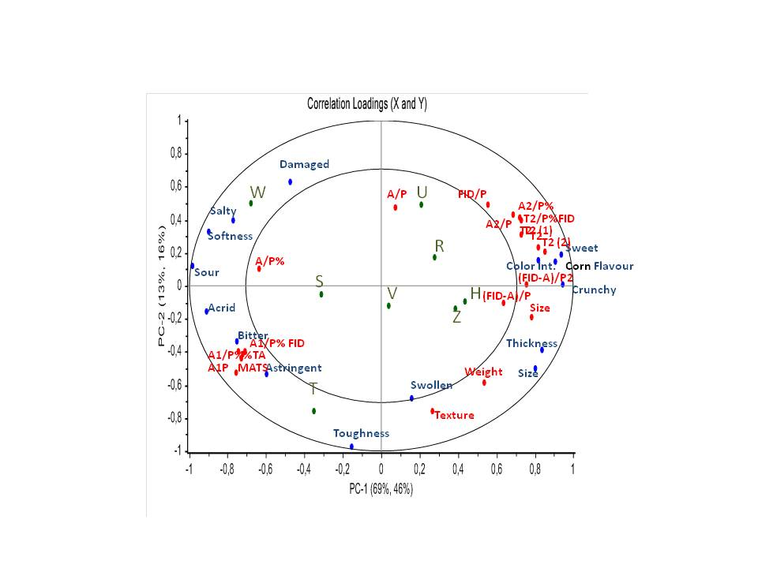

**Figure 4.** PCR Descriptive Sensory data *vs* Instrumental data. Correlation Plot.

Given these evidences, predictive models could be computed to predict relevant sensory properties of sweet corn samples. This is not done here since the relative small number of observations used for the main aim of the VeggiEAT project it is not sufficient to adequately test the goodness of predictive models. However, as an example, the results of a Partial Least Square (PLS) predictive model of sweet intensity in sweetcorn samples is reported in Figure 5. It is possible to note that sweetness predicted value is acceptable for 5 out of 8 samples. This is promising for setting up a predictive model of sensory properties based on instrumental analysis in a definite domain such as a productive process. In fact, having one or more reference samples, predictive models could be applied as fast method to screen the conformity of samples to a given sensory standard.



**Figure 5.** PLS1 Predictive model of sweet intensity in sweet corn samples from instrumental analysis. Comparison between predicted and measured (by DA panel) data.

*Peas*

The measured instrumental parameters from peas samples are reported in table 4.

**Table 4**. Chemical and instrumental parameters measures in pea samples.

|  |  |  |  |  |  |  |  |  |
| --- | --- | --- | --- | --- | --- | --- | --- | --- |
| Samples | Size | Weight | Colour | | | Sugar | Dry Mat | Texture |
|  | (mm) | (mg) | L | a | b | (%) | (%) | (N.m.) |
| A | 9.23 | 499.48 | 52.43 | -1.31 | 14.49 | 0.11 | 0.22 | 36.00 |
| B | 8.81 | 377.20 | 52.13 | -0.86 | 16.09 | 0.14 | 0.23 | 27.00 |
| D | 9.82 | 415.36 | 52.20 | -1.36 | 16.19 | 0.11 | 0.23 | 41.00 |
| E | 8.63 | 367.20 | 52.19 | -1.64 | 15.38 | 0.08 | 0.19 | 38.00 |
| F | 9.76 | 525.48 | 55.27 | -1.76 | 19.49 | 0.09 | 0.23 | 29.00 |
| J | 7.24 | 227.36 | 52.13 | -1.01 | 15.89 | 0.06 | 0.20 | 38.00 |
| L | 6.76 | 191.16 | 52.45 | -1.42 | 16.37 | 0.10 | 0.21 | 18.00 |
| O | 7.31 | 201.04 | 53.27 | -1.48 | 15.47 | 0.09 | 0.18 | 18.00 |
| P | 7.12 | 240.16 | 55.67 | -1.45 | 16.01 | 0.05 | 0.20 | 43.00 |
| Q | 6.60 | 205.00 | 52.77 | -1.19 | 15.73 | 0.10 | 0.24 | 31.00 |

In order to explore the relationship between sensory properties and instrumental data, a Principal Component Regression was computed. The descriptive sensory data were assumed as X matrix so that instrumental measurements were projected onto a sensory map describing similarities and difference among samples (Fig.6).

**Figure 6.** PCR Descriptive Sensory data *vs* Instrumental data. Correlation Plot.

The graph clearly shows that traditional quality control parameters do not predict the sensory

properties of products. Color parameters (L, a and b), dry matter and “texture” are not significantly correlated to any of the sensory attributes describing pea samples. As expected, obviously, physical measurements (weight and size) were correlated with the visual valuation of seed size. The only parameter that is related to sensory attributes is the sugar content, which is correlated with the perceived sweetness, other flavours and texture descriptors. Considering that these attributes tend to drive liking for peas in both elderly and adolescents, sugar content should be considered (as it is) and important parameter in quality control.

**Task 2.2 (consumer test design- Optimisation of parameters of the free sorting task- FST method.)**

*Number of samples in sorting task*

In order to check the number of samples to be tested in a free sorting task, independent pilot studies were conducted at Bonduelle Research Centre, Lille, France and at Florence University (Italy) with adolescents and elderly, respectively. Independent panels of twenty subjects each were asked to perform the Free Sorting Task of peas and sweet corn samples on eight, ten and twelve samples. Each sample series included a replicated sample. The number of subject including the replicated sample in the same group when performing the sorting task was counted. This was always around the 50% of the total number of subjects, independently from the number of products. Thus, it was concluded that up to twelve, the number of products used in free sorting task does not affect the reliability of results. Of course these evidences do not have a general validity, since they are relative to the products of interest in the VeggiEAT project. Performing a sorting task with ten-twelve products is common in sensory studies run on many food categories (see Lawless, H.T., and Heymann, 2010). Furthermore, canned vegetables have not a complex sensory profile and do not determine sensory fatigue.

*Stability of sorting configuration*

Sorting data from adolescents and elderly from Italy and France were used to study the stability of sorting configuration. For each age and country group a similarity matrix was generated by counting the number of times each pair of stimuli was sorted in the same group. This similarity matrix was obtained by summing the individual 0⁄1 matrices form each age group in each country and submitted to multidimensional scaling (MDS) that produces a spatial representation of the product similarity in which products are represented by points on a map. The points are arranged in this representation so that the distances between pairs of points reflect as well as possible the similarities among the pairs of stimuli.

Based on previous studies (Faye at al. 2006; Blancher et al. 2012 and Vidal et al. 2013), the stability of sample configurations was evaluated by simulating repeated experiments. Random subsets of different size (m = 20, 30, 40…, N) were generated from the original data set of N consumers for each age group in each country. In this study, a simple random sample procedure was adopted and each “m” was replicated ten times. For each subset sample coordinates in the first two dimensions of the sorting map were obtained. The agreement between each of these configurations and the reference configuration (obtained with all the consumers) was evaluated by computing the RV coefficient (Abdi, 2010) between the first two dimensions of the relevant sorting map. The RV coefficient is a measure of the similarity between two factorial configurations, which takes the value of 0 if the configurations are uncorrelated, and the value of 1 if the configurations are homothetic. RV values from 0.90 (Vidal et al. 2013), and 0.95 (Blancher et al. 2012) have been proposed to consider a sensory map as stable and therefore these values were considered in the present study to assess the stability of sample configurations from sorting. In addition to this approach, the stability of configurations was also derived by the computation of the RV between sorting configuration and both the perceptual map from Descriptive Analysis (DA) and the Internal Preference Map computed on liking scores from N respondents (IPM, a Principal Component Analysis computed on liking scores).

To evaluate the stability of sorting configurations RV values were computed as described above. Results are presented here considering first elderly and adolescent sorting data for peas, a familiar product with both age groups in both countries.

Table 5 reports the results relative to peas samples for elderly respondents from both countries.

Considering the “FST N” columns which reports the RV values between the sorting configurations obtained from all subject (N) and from “m” number of subjects it can be noted that a value of 0.95 is reached with 20-30 subjects for French respondents and 30-40 for Italians. Furthermore, when “m” increases the RV value between sorting and DA configuration increases too. Thus, the trend of these RVDA values can be useful to identify the number of subjects necessary to obtain a stable sorting configuration in relation to a perceptual map from descriptive data.

This is evident considering the graph reported in Figure 7. When “m” is equal or higher than 50, the RVDA curve tends to reach a plateau. The trend tends to be similar in the two countries.

**Table 5**: RV coefficient values of sample configurations in the first two dimensions of the sorting configuration with respect to the reference (FST N), DA, and IPM maps as function of the number of consumers considered in the panels for peas. Data from Italian and French elderly respondents.

|  |  |  |  |  |  |  |
| --- | --- | --- | --- | --- | --- | --- |
|  | RV coefficient | | | | | |
|  | *France* | | | *Italy* | | |
| *Subjects* | FST (N) | IPM | DA | FST (N) | IPM | DA |
| *(m)* |
| 20 | 0.949 | 0.750 | 0.862 | 0.872 | 0.686 | 0.734 |
| 30 | 0.973 | 0.730 | 0.871 | 0.935 | 0.687 | 0.797 |
| 40 | 0.981 | 0.766 | 0.881 | 0.973 | 0.737 | 0.830 |
| 50 | 0.987 | 0.784 | 0.891 | 0.978 | 0.726 | 0.845 |
| 60 | 0.992 | 0.789 | 0.900 | 0.991 | 0.748 | 0.852 |
| 70 | 0.995 | 0.781 | 0.896 | 1.000 | 0.755 | 0.867 |
| 80 | 0.998 | 0.773 | 0.899 |  |  |  |
| 90 | 0.999 | 0.775 | 0.900 |  |  |  |
| 98 | 1.000 | 0.779 | 0.900 |  |  |  |

When “m” increases the RVIPM relating sorting configurations to Internal Preference Maps from N subjects increases too. This implies that both sensory and hedonic dimensions underlying product perception can be interpreted from the results of a sorting task. When ”m” is equal or higher than 50 RVIPM values tend to be stable.

Considering all RV curves, it is possible to say that a panel of 50 subjects is appropriate to study elderly perception of similarities and dissimilarities among canned pea samples.

**Figure 7.** RV coefficient values of sample configurations in the first two dimensions of the sorting configuration with respect to the reference (FST N), DA and IPM maps as function of the number of consumers considered in the panels for peas. Data from French elderly respondents. Bars represent standard error.

Table 6 reports the results from pea sample set relative to both Italian and French adolescents. The RVFST(N) computed between the sorting configurations obtained from all subject (N) and those from an increasing “m” number of subjects reaches a value 0.95 with 30 subjects both in France and Italy. As already observed in elderly respondents, the RVDA increases with the number of subjects. This is evident considering the graph reported in Figure 8. When “m” is equal or higher than 50 both RVIPM and RVDA curves tend to reach a plateau. The trend is similar in both countries.

Based on RV curves, a panel size of 50 subjects is appropriate to run a sorting task with canned peas.

**Table 6.** RV Coefficient values of sample configurations in the first two dimensions of the Sorting configuration with respect to the reference (FST N), DA and IPM maps as function of the number of consumers considered in the panels for peas. Data from Italian and French adolescent respondents.

|  |  |  |  |  |  |  |
| --- | --- | --- | --- | --- | --- | --- |
|  | RV coefficient | | | | | |
|  | *France* | | | *Italy* | | |
| *Subjects* | FST (N) | IPM | DA | FST (N) | IPM | DA |
| *(m)* |
| 20 | 0.905 | 0.618 | 0.801 | 0.929 | 0.652 | 0.830 |
| 30 | 0.948 | 0.662 | 0.822 | 0.952 | 0.639 | 0.856 |
| 40 | 0.953 | 0.666 | 0.839 | 0.975 | 0.643 | 0.873 |
| 50 | 0.976 | 0.677 | 0.871 | 0.981 | 0.651 | 0.891 |
| 60 | 0.984 | 0.667 | 0.870 | 0.985 | 0.688 | 0.900 |
| 70 | 0.989 | 0.682 | 0.872 | 1.000 | 0.755 | 0.867 |
| 80 | 0.991 | 0.685 | 0.882 | 0.991 | 0.670 | 0.899 |
| 90 | 0.995 | 0.690 | 0.885 | 0.994 | 0.684 | 0.902 |
| 100 | 1.000 | 0.686 | 0.886 | 1.000 | 0.687 | 0.905 |

**Figure 8.** RV coefficient values of sample configurations in the first two dimensions of the sorting configuration with respect to the reference (FST N), DA and IPM maps as function of the number of consumers considered in the panels for peas. Data from Italian adolescents. Bars represent standard error.

Sorting data on sweetcorn were analyzed too. Table 7 reports the results referred to RV values from elderly in both countries.

**Table 7.** RV coefficient values of sample configurations in the first two dimensions of the sorting configuration with respect to the reference (FST N), DA and IPM maps as function of the number of consumers considered in the panels for sweetcorn. Data from Italian and French elderly respondents.

|  |  |  |  |  |  |  |
| --- | --- | --- | --- | --- | --- | --- |
|  | RV coefficient | | | | | |
|  | *French* | | | *Italian* | | |
| *Subjects* | FST (N) | IPM | DA | FST (N) | IPM | DA |
| *(m)* |
| 20 | 0.832 | 0.536 | 0.705 | 0.685 | 0.482 | 0.589 |
| 30 | 0.839 | 0.529 | 0.728 | 0.728 | 0.427 | 0.606 |
| 40 | 0.883 | 0.534 | 0.744 | 0.790 | 0.517 | 0.716 |
| 50 | 0.922 | 0.548 | 0.784 | 0.843 | 0.483 | 0.713 |
| 60 | 0.953 | 0.553 | 0.796 | 0.919 | 0.503 | 0.707 |
| 70 | 0.955 | 0.543 | 0.799 | 1.000 | 0.474 | 0.736 |
| 80 | 0.982 | 0.537 | 0.814 |  |  |  |
| 90 | 0.991 | 0.547 | 0.817 |  |  |  |
| 100 | 1.000 | 0.540 | 0.819 |  |  |  |

Considering the RVFST(N) values, it is evident that the stability of sorting configurations (RV=0.95) is reached with a number of subjects ranging from 60 to 70 and that RVDA trend tends to be stable when the number of subjects is higher than 70 (Fig. 9). A similar trend can be observed in Italian respondents. In fact, with 60 subjects the RV is lower than 0.95 (Tab.7). The RVIPM valuescomputed on sweet corn sorting data are lower than the ones computed on peas. This implies that sorting configurations are less related to liking responses compared to what observed in peas and that RVIPM is not informative in determining an appropriate number of subjects to perform a sorting task on this product.

Results from adolescents (Tab.8) show that in the case of French respondents a stable sorting configuration is reached with a panel composed with 50-60 subjects. Also, the same panel size seems to give sorting configurations that are stable in relation to both DA and preference maps. However, when Italian data are considered (Fig.10), the number of subjects required to obtain an RVFST(N) equal or higher of 0.95 ranges between 60-70 and only a “m” values higher than 70 stabilize the RVDA.

Based on these evidences it can be assumed that a panel of 60-70 subjects is appropriate to perform a sorting task on canned sweet corn samples, but a larger size could be considered. The reasons of differences in the results from peas and sweet corn and differences between countries and age groups can be explained considering the different familiarity of the subject groups with the two products.

On the basis of the ratings collected with the same subjects participating to the sorting task, both elderly and adolescent tend to be more familiar with peas than with sweet corn. Independently from the country, the difference in familiarity with sweetcorn is large when comparing elderly and adolescents. In fact, the familiarity ratings from adolescents are higher than those from elderly (see report on task 2.3). Among adolescents, familiarity with sweetcorn is higher in France than in Italy. Thus, it seems that the size of panels should be considered in relation to the familiarity of respondents with the product under observation.

**Figure 9.** RV coefficient values of sample configurations in the first two dimensions of the sorting configuration with respect to the reference (FST N), DA and IPM maps as function of the number of consumers considered in the panels for sweetcorn. Data from French elderly respondents. Bars represent standard error.

**Table 8.** RV Coefficient values of sample configurations in the first two dimensions of the Sorting configuration with respect to the reference (FST N), DA and IPM maps as function of the number of consumers considered in the panels for sweetcorn. Data from Italian and French adolescent respondents.

|  |  |  |  |  |  |  |
| --- | --- | --- | --- | --- | --- | --- |
|  | RV coefficient | | | | | |
|  | *French* | | | *Italian* | | |
| *Subjects* | FST (N) | IPM | DA | FST (N) | IPM | DA |
| *(m)* |
| 20 | 0.893 | 0.617 | 0.778 | 0.768 | 0.648 | 0.682 |
| 30 | 0.901 | 0.650 | 0.802 | 0.858 | 0.737 | 0.792 |
| 40 | 0.947 | 0.652 | 0.821 | 0.898 | 0.729 | 0.788 |
| 50 | 0.951 | 0.670 | 0.827 | 0.914 | 0.754 | 0.807 |
| 60 | 0.979 | 0.647 | 0.832 | 0.927 | 0.762 | 0.834 |
| 70 | 0.990 | 0.658 | 0.831 | 0.975 | 0.740 | 0.836 |
| 80 | 0.988 | 0.666 | 0.839 | 0.973 | 0.750 | 0.859 |
| 90 | 0.996 | 0.659 | 0.838 |  |  |  |
| 100 | 1.000 | 0.663 | 0.842 | 1.000 | 0.687 | 0.905 |

**Figure 10.** RV coefficient values of sample configurations in the first two dimensions of the sorting configuration with respect to the reference (FST N), DA and IPM maps as function of the number of consumers considered in the panels for sweet corn. Data from Italian adolescents. Bars represent standard error.

**Task 2.3 (consumer tests- Evaluation of sensory variation discrimination according to consumer background, age and nationality, applying a free sorting test and collecting liking responses).**

*Free sorting task*

The results for both teenagers and elderly people and both peas and sweetcorn are presented here. The total dissimilarities matrices were built for each vegetable, for each population and each country and then analysed with MDS. Based on the observed stress values the first two dimensions were considered for all the obtained configurations. For each product, results from each age group and country are presented and discussed.

*Canned Peas*

Sorting configurations from adolescents and elderly were compared across countries (IT, FR and DK) by computing the RV coefficient (Tables 9 and 10). Each configuration was also compared with the perceptual map computed on descriptive analysis (DA) data already presented in results from task 2.1. It can be noted that the correlation between configurations is quite high in all possible cross-country pair comparisons. For both elderly and adolescents, the RV values are never lower than 0.91. This means that, within each age group, the configuration of samples resulting from the sorting task is very similar across countries. It can also be noticed that all sorting configurations are highly correlated with the perceptual map computed on descriptive data. The minimum RV value is 0.82 (Danish elderly) while the maximum 0.90 (for both Italian adolescents and French elderly). These results suggest that spatial configurations from sorting task depict the same similarities and differences among samples described by means the descriptive analysis conducted with trained subjects. Furthermore, they suggest that the same sensory differences among samples drove the sorting task across ages and countries. Considering the high correlation between sorting maps across countries, sorting data were grouped by age groups and two general spatial configurations were obtained (Figures 11 and 12). The intensities of sensory attributes from the descriptive analysis were projected on the sorting configurations to facilitate the interpretation of the maps. In both maps, it is possible to identify five sample groups. Along the first dimension, from the left to the right, samples A, D, B, E and F are separated from the rest and opposed to sample Q. The second dimension, from the bottom to the top, further separates samples P and J from O and L on the right side of the map, and F from A, D, B and E on the left side.

The two configurations are very similar among age groups too and replicate samples (O and O’) are very close on the maps, meaning that they have been frequently sorted in the same group by the subjects. This indicates a good reliability of the results. Product coordinates along the first dimension are highly and significantly (p < 0.05) correlated with the intensity of the attribute “seed size” underlining the importance of appearance in sorting the samples. Along the second dimension the correlation of sample coordinates is significant for two blocks of sensory variables opposed to each other. In fact, in the bottom of the map, the attributes umami, sweet, salty, soft, melt in the mouth, cooked peas, onion and cooked vegetables are opposed to the attributes bitter, “skin hardness”, sour, acrid and metallic. These sensory attributes are relevant for consumer (both adolescents and elderly) perception of flavour differences and similarities among samples. Attributes falling in the inner ellipse of the map are not significantly correlated to either the first or the second dimension.

In the sorting task respondents were left free to add a descriptor for each sample group they formed. Table 11 reports the list of terms that were generated by adolescents while table 12 the terms from elderly. Both sensory and hedonic terms were elicited in both age groups.

In general Italian and French respondents tended to elicit more terms than British and Danish. This difference is more evident when comparing results from adolescents. A possible reason for this evidence is a higher use of and familiarity with canned peas in France and Italy.

Elicited sensory terms were referred to appearance, flavour and texture in all countries independently from the age group. A simple way to look at the relative importance of terms (after grouping them on a semantic base) is to compute the occurrences of elicitation across subjects and represent them in a “word cloud” as reported in Figures 13 and 14 from adolescents and elderly, respectively. It is easy to deduct from the size of the word that frequently elicited terms by adolescents were referred to size (big, small), texture (soft, melt in the mouth) and flavour (sweet) or to the opposition pleasant vs unpleasant. In elderly, the frequently elicited terms were “sweet” followed by “not tasty” and pleasant.

A consistent and prevalent association of sensory terms as well as positive or negative of hedonic terms with sample groups allows the observer to interpret the hedonic relevance of perceived differences among samples. In other word, a sorting configuration can be interpreted in relation to sensory as well as hedonic dimensions driving the sorting task. With this purpose, the occurrences with which each sample was associated with each term were counted per country and a Principal Component Regression (PCR) was computed independently for each age group. The matrix of occurrences (% in relation to the total in each country) organized in four country blocks (IT, FR, UK, DK) was assumed as X matrix so that sensory data from descriptive analysis (Y matrix) were projected onto a map describing similarities and difference among samples in relation to term use frequency across countries (Figures 15 and 16). Considering the map relative to adolescent respondents it can be noted that samples J and P are separated from the rest because they were more frequently than others associated with terms describing negative sensory properties (e.g. lack of taste, wrong texture, bitterness) and negative hedonic terms (e.g. bad, unpleasant, disgust). These frequencies are correlated to the intensity of the attributes bitter, sour, acrid and skin hardness. On the contrary, the top side of the map is associated with the sensory descriptors sweet, tasty, soft, salty. These terms are also correlated to positive hedonic terms (e.g. pleasant, good) and to the intensity of the sensory attributes sweet, soft, salty, umami, cooked peas and vegetables, onion, melty.

The opposition big versus small is used to discriminate samples A, B, D and E from L, O and Q. These terms were correlated to the intensities of the attributes seed size, damaged and swollen.

The map from elderly data tends to reproduce the same information. However, it is interesting to note that the separation along the first dimension, from the right to the left, that separates disliked products J and P from the rest of samples, is strongly associated with negative texture and taste proprieties. The second dimension is associate to positive taste and texture terms in the bottom of the map separating samples O and L from samples A, B, D and E on the top of the graph that is mainly associated with the terms related to sample size.

|  |  |  |  |  |  |  |  |  |  |  |  |  |  |  |  |  |  |  |  |  |  |  |  |  |  |  |  |  |  |  |  |  |  |  |  |  |  |  |  |  |  |  |  |  |  |  |  |  |  |  |  |  |  |  |  |  |  |  |  |  |  |
| --- | --- | --- | --- | --- | --- | --- | --- | --- | --- | --- | --- | --- | --- | --- | --- | --- | --- | --- | --- | --- | --- | --- | --- | --- | --- | --- | --- | --- | --- | --- | --- | --- | --- | --- | --- | --- | --- | --- | --- | --- | --- | --- | --- | --- | --- | --- | --- | --- | --- | --- | --- | --- | --- | --- | --- | --- | --- | --- | --- | --- | --- |
| **Table 9.** Comparison between pea samples sorting configurations among adolescents: RV values   |  |  |  |  |  | | --- | --- | --- | --- | --- | |  | RV Coefficient | | | | |  | *FR* | *IT* | *DK* | *QDA* | | FR | 1.00 | 0.92 | 0.91 | 0.88 | | IT | 0.92 | 1.00 | 0.91 | 0.90 | | DK | 0.91 | 0.91 | 1.00 | 0.83 | | QDA | 0.88 | 0.90 | 0.83 | 1.00 | | **Table 10:** Comparison between pea samples sorting configurations among elderly: RV values   |  |  |  |  |  | | --- | --- | --- | --- | --- | |  | RV Coefficient | | | | |  | *FR* | *IT* | *DK* | *QDA* | | FR | 1.00 | 0.93 | 0.94 | 0.90 | | IT | 0.93 | 1.00 | 0.90 | 0.86 | | DK | 0.94 | 0.90 | 1.00 | 0.82 | | QDA | 0.90 | 0.86 | 0.82 | 1.00 | |
| **Figure 11**. FST configuration: Pea samples from adolescents. Projection of sensory descriptors from DA | **Figure 12**. FST configuration: Pea samples from elderly. Projection of sensory descriptors from DA |

**Table 11.** Terms elicited in Free Sorting Task by adolescents (pea samples)

|  |  |  |  |  |
| --- | --- | --- | --- | --- |
| Sensory modality | Terms | | | |
|  | *Italy* | *France* | *United Kingdom* | *Denmark* |
|  |  |  |  |  |
| Flavor | Saporiti | Avec Du Goût | Plain |  |
| Non saporiti | Pas De Goût | Flavourless | Bitter |
| Poco saporiti | Goût Fume | Bitter | Sød |
| Salati | Sucré | Sweet | Salt |
| Amari | Amer | Salty | Sur |
| Acidi | Salé |  |  |
| Dolci | Non Salé |  |  |
|  |  |  |  |  |
| Texture | Buccia dura | Sec | Hard | Melet |
| Buccia morbida | Mou | Soft | Blød |
| Secchi | Moelleux | Mushy | Most |
| Farinosi | Farineux | Watery | Vandet |
| Pastosi | Pas Assez Cuit | Dry | Tør |
| Compatti | Cuit A Point |  | Fast |
| Duri | Plein D'Eau |  | Saftig |
| Acquosi | Croquant |  |  |
| Morbidi | Dur |  |  |
| Non cotti |  |  |  |
|  |  |  |  |  |
| Appearance | Grandi | Gros | Big | Stor |
| Medi | Petit | Small | Lille |
| Piccoli |  | Same colour |  |
| Chiari |  |  |  |
| Colore acceso |  |  |  |
|  |  |  |  |  |
| Hedonics | Gradevoli | Bon | Pleasant | Fin |
| Non gradevoli | Pas Bon | Unpleasant | Ulækkert |
| Poco gradevoli | Sent Pas Bon | Extremely unpleasant | God |
| Buon odore | Sent Bon | Horrible smell | Dårlig |
| Cattivo odore | Bon Goût |  | Kedelig |
| Buona consistenza | Mauvais Goût |  |  |
| Aspetto gradevole | Goût Spécial |  |  |
| Andati a male | Texture Agréable |  |  |

**Table 12.** Terms elicited in Free Sorting Task by elderly (pea samples)

|  |  |  |  |  |
| --- | --- | --- | --- | --- |
| Sensory modality | Terms | | | |
|  | *Italy* | *France* | *United Kingdom* | *Denmark* |
|  |  |  |  |  |
| Flavour | Piselli | Goûteux | Flavoursome | Smagsløs |
| Saporiti | Fade | Bitter | Ærter |
| Poco saporiti | Pas Salé | Salty | Salt |
| Non saporiti | Pas Sucré | Sweet | Sød |
| Salati | Amer | Too Sweet | Lidt sød |
| Amari | Salé | Less Sweet |  |
| Acidi | Sucré |  |  |
| Dolci |  |  |  |
| Poco dolci |  |  |  |
|  |  |  |  |  |
| Texture | Buccia dura | Ferme | Dry | Tør |
| Pastosi | Croquant | Floury | Melet |
| Farinosi | Mou | Hard | Hård |
| Morbidi | Farineux | Soft | Blød |
| Duri | Peau Dure | Juicy | God konsistens |
| Buona cottura | Fondant | Medium texture | Grov/ru |
| Crudi | Pâteux | Mushy | Overkogt/udkogt |
| Buccia sottile | Tendre | Watery |  |
|  | Peau Epaisse |  |  |
|  | Dur |  |  |
|  |  |  |  |  |
| Appearance | Grandi | Gros | Big | Lille størrelse |
| Piccoli | Couleur Claire | Small | Stor størrelse |
| Danneggiati | Petit | Poor Colour |  |
|  | Onctueux |  |  |
|  |  |  |  |  |
| Hedonics | Gradevoli | Bon | Pleasant | God smag |
| Non gradevoli | Pas Bon | Unpleasant | Dårlig smag |
| Poco gradevoli | Texture Désagreable | Extremely unpleasant | Frygtelig |
| Cattivo odore | Bon Goût | Good colour | Kedelig |
| Buona consistenza | Mauvais Goût | Processed | God |
| Naturali | Fin | Reasonable | Dårlig |
| Avariati | Bonne Textute |  |  |
|  | Pas Assez Cuisiné |  |  |
|  | Bien Cuisiné |  |  |

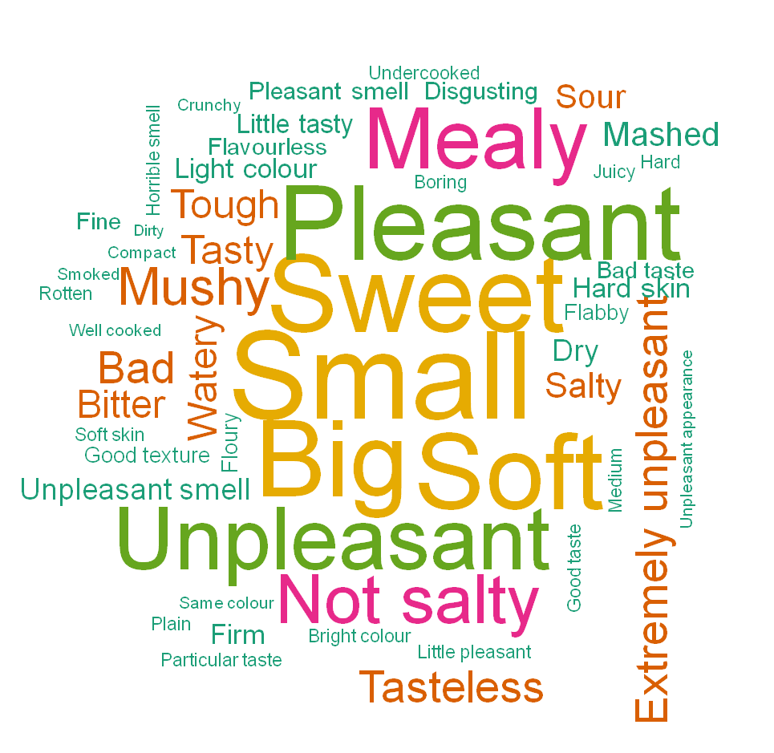

**Figure 13.** “Word cloud” with terms elicited in the sorting task on peas by adolescent respondents in Italy, France, UK and Denmark.

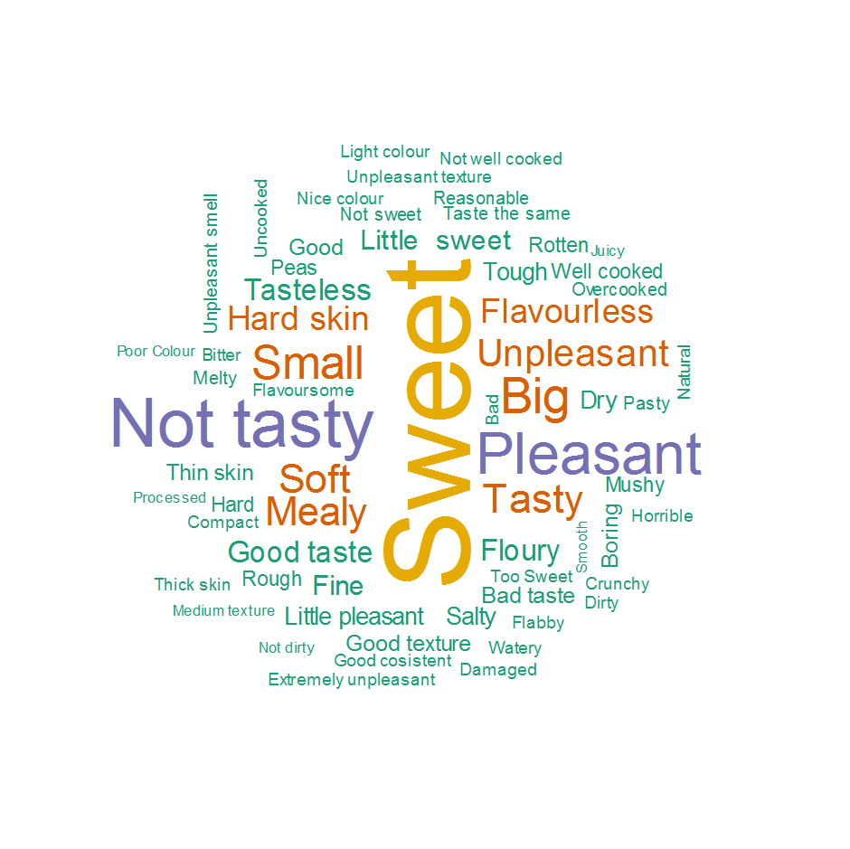

**Figure 14.** “Word cloud” with terms elicited in the sorting task on peas by elderly respondents in Italy, France, UK and Denmark

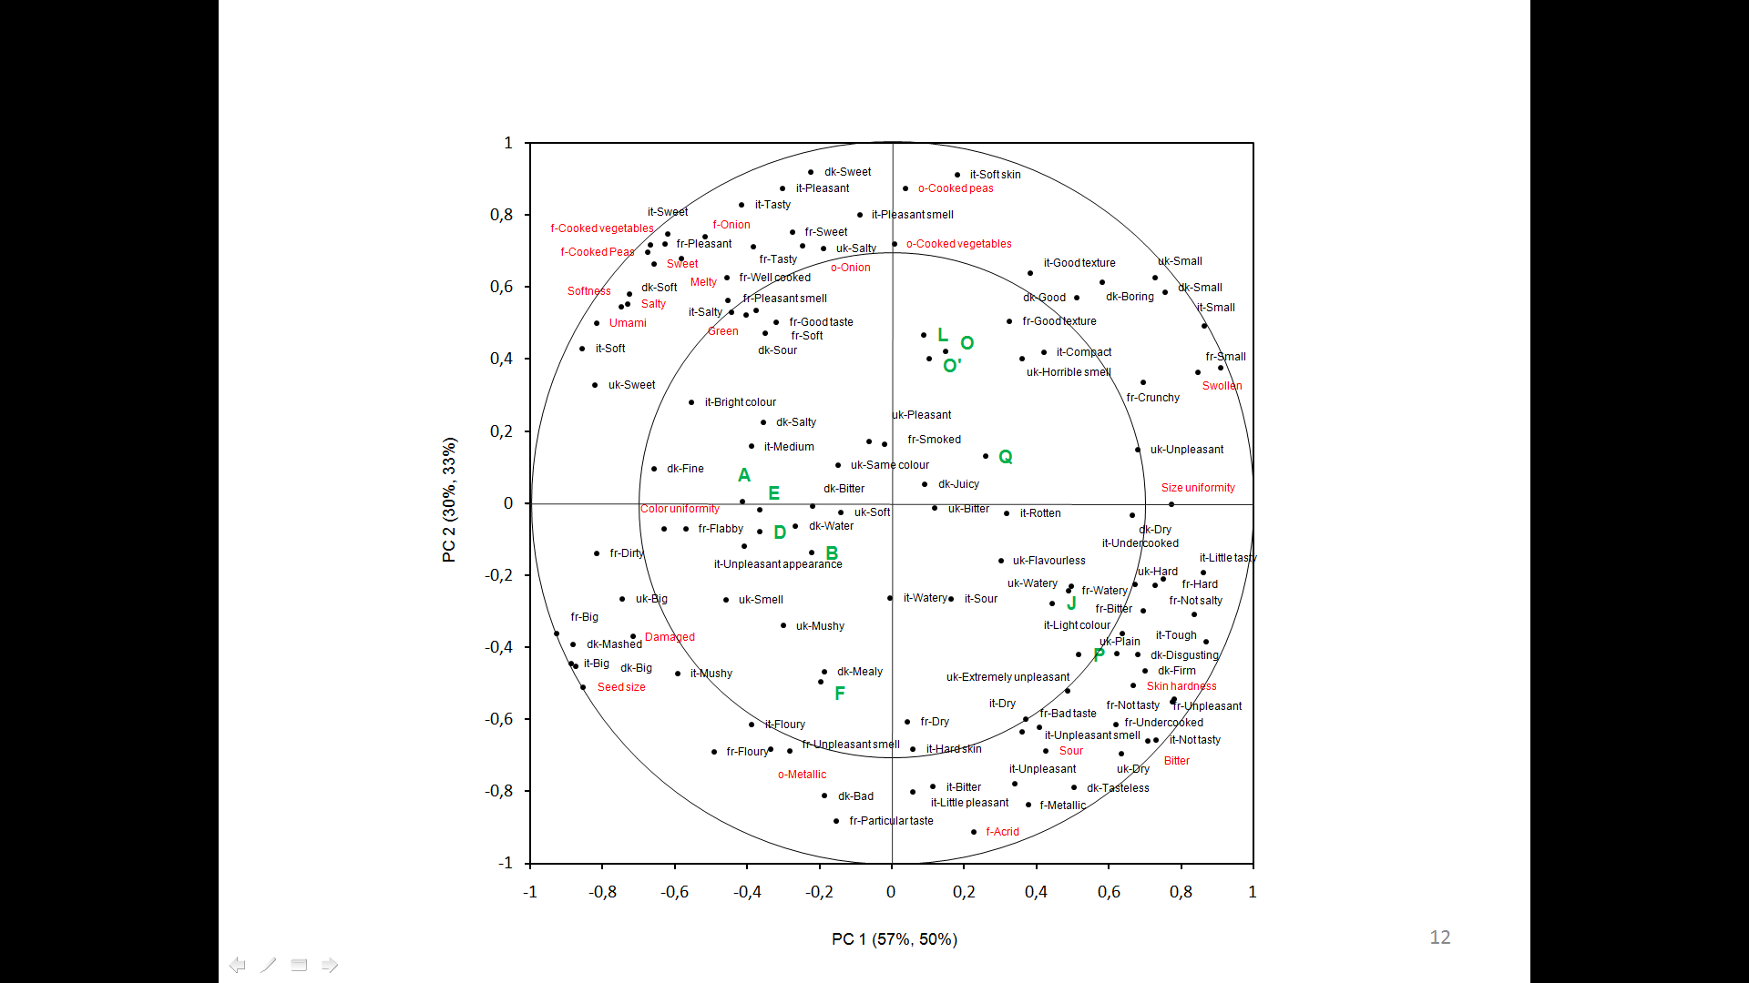

**Figure 15.** Principal Component Regression: terms (in black) generated by adolescents from Italy (it), France (fr), UK (uk), and Denmark (dk) in the sorting task vs the sensory descriptors (in red) from DA. Correlation loading plot. Pea samples. Letters (in green) identify the products.

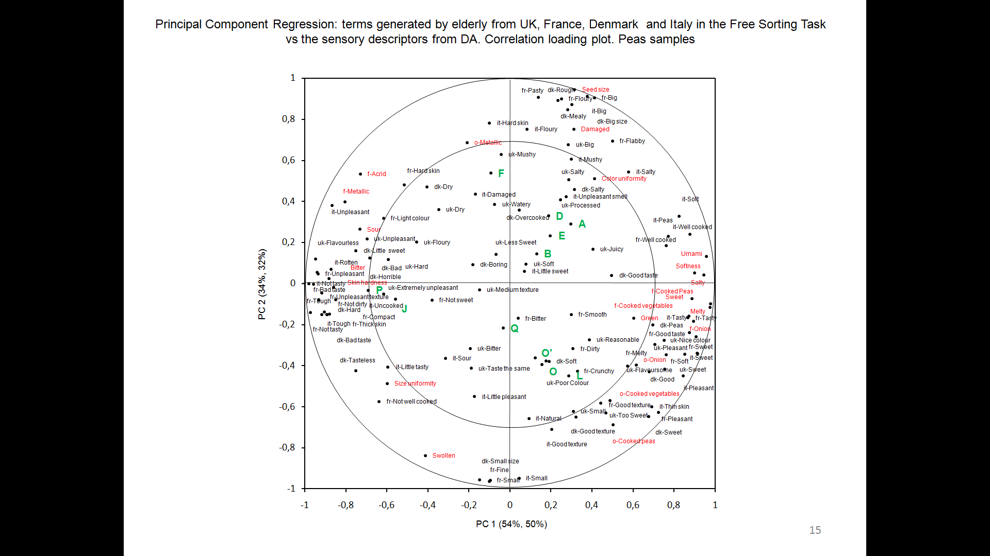

**Figure 16.** Principal Component Regression: terms (in black) generated by elderly from Italy (it), France (fr), UK (uk) and Denmark (dk) in the sorting task vs the sensory descriptors (in red) from DA. Correlation loading plot. Pea samples. Letters (in green) identify the products.

*Canned Sweet corn*

Sorting configurations from adolescents and elderly were compared across countries (IT; FR and DK) by computing the RV coefficient (Tables 13 and 14). Each configuration was also compared with the perceptual map computed on descriptive analysis (DA) data.

In the case of adolescents, the correlation between configurations is quite high in all possible cross country pair comparisons. The RV values are never lower than 0.82. Even if the Italian configuration tends to slightly differ from the French and Danish ones, the configuration of samples resulting from the sorting task is very similar across countries. It can also be noticed that all sorting configurations are highly correlated with the perceptual map computed on descriptive data. The RV value ranges from 0.84 to 0.86 across countries. These results suggest that spatial configurations from sorting task depict the same similarities and differences among samples described by means the descriptive analysis conducted with trained subjects. Furthermore, they suggest that the same sensory differences among samples drove the sorting task across countries. Considering the high correlation between sorting maps across countries, sorting data from adolescents were grouped by age groups and a general spatial configurations was obtained (Figure 17). The intensities of sensory attributes from the descriptive analysis were projected on the sorting configurations to facilitate the interpretation of the map.

It is possible to identify three sample groups on the map. Along the first dimension, from the left to the right, samples W, T, and S are separated from the rest. The second dimension, from the bottom to the top, further separates samples R and H from V, U and Z, on the left side of the map.

The replicate samples (H and H’) are very close on the map. This indicates a good reliability of the results. Product coordinates along the first dimension are highly and significantly (p < 0.05) correlated with the intensity of the attribute softness, sour, salty, and bitter on the right side and crunchiness, sweet, yellow and the strength of sweet corn flavour on the left side. This result makes clear that both texture and taste properties played a role in sorting the samples.

Cross-country differences were more evident when comparing the configurations among elderly (Table 14). The RV value ranges from 0.67 (IT vs FR) to 0.85 (FR vs DK). The sorting configurations are correlated with the perceptual map computed on descriptive data, but the RV values tend to be lower than the ones observed in adolescents. These results can be explained considering the lower familiarity with sweetcorn in elderly than in adolescents, particularly in Italy and France. As can be seen from figures 18 (a-c) the spatial configurations from the considered three countries have similarities and differences. In all countries, elderly separate samples H (and its replicate H’) from T, W and S along the first dimension of the relative maps. At same time samples Z, U, R and V are differently sorted across countries. This evidence suggests that, across nations, respondents agree on the main differences among samples, but differently categorize samples with less clear differences. Looking at the correlation between samples coordinates along the first two dimensions of the configurations and the intensity of the sensory attributes from descriptive analysis it can be noted that in the three maps the first dimension is always strongly correlated to the opposition sweet vs sour and crunchy vs soft. However, the number and the nature of the sensory attributes significantly (p<0.05) correlated with samples coordinates vary across countries. It is lower in the case of the Italian configuration (eight attributes) and higher for French respondents (eleven). Furthermore, attributes like saltiness and yellow colour are significantly correlated with product coordinates in the case of French and Danish maps, but not in the case of the Italian map. These results suggest different criteria in discriminating among samples that can be due to a varied familiarity with and usage of the product as well as a higher impact of individual differences in sample perception in one country than in others.

The number of terms generated by elderly in the sorting task (Tab. 15) shows that there is a difference in the number and the nature of the terms generated across countries. Italians and Danish respondents did not used terms related to appearance while French and British did. Italian respondents generated a relatively higher number of flavour descriptors while French respondents focused their description of the differences among groups on texture. These differences may contribute in understanding the differences in sorting configurations among elderly. Differences in number and nature of the terms elicited by adolescents (Table 16) across countries are less evident. They tend to describe the sample groups they generated by the sorting task mainly in relation to flavour and texture properties of samples and no clear differences are observed with the only exception of the lack of appearance descriptors in the Danish list of terms.

The most elicited term among both adolescents and elderly was ”sweet”.

|  |  |  |  |  |  |  |  |  |  |  |  |  |  |  |  |  |  |  |  |  |  |  |  |  |  |  |  |  |  |  |  |  |  |  |  |  |  |  |  |  |  |  |  |  |  |  |  |  |  |  |  |  |  |  |  |  |  |  |  |  |  |
| --- | --- | --- | --- | --- | --- | --- | --- | --- | --- | --- | --- | --- | --- | --- | --- | --- | --- | --- | --- | --- | --- | --- | --- | --- | --- | --- | --- | --- | --- | --- | --- | --- | --- | --- | --- | --- | --- | --- | --- | --- | --- | --- | --- | --- | --- | --- | --- | --- | --- | --- | --- | --- | --- | --- | --- | --- | --- | --- | --- | --- | --- |
| **Table 13.** Comparison between sweet corn sorting configurations among adolescents: RV values   |  |  |  |  |  | | --- | --- | --- | --- | --- | |  | RV Coefficient | | | | |  | *FR* | *IT* | *DK* | *QDA* | | FR | 1.00 | 0.82 | 0.90 | 0.84 | | IT | 0.82 | 1.00 | 0.83 | 0.86 | | DK | 0.90 | 0.83 | 1.00 | 0.85 | | QDA | 0.84 | 0.86 | 0.85 | 1.00 | | **Table 14.** Comparison between sweet corn sorting configurations among elderly: RV values   |  |  |  |  |  | | --- | --- | --- | --- | --- | |  | RV Coefficient | | | | |  | *FR* | *IT* | *DK* | *QDA* | | FR | 1.00 | 0.67 | 0.85 | 0.81 | | IT | 0.67 | 1.00 | 0.73 | 0.73 | | DK | 0.85 | 0.73 | 1.00 | 0.85 | | QDA | 0.81 | 0.73 | 0.85 | 1.00 | |
| **Figure17.** FST configuration from adolescents: Sweet corn samples. Projection of sensory descriptors from DA | **Figure 18a**. FST configuration from French elderly: Sweet corn samples. Projection of sensory descriptors from DA |
| **Figure18b.** FST configuration from Italian elderly: Sweet corn samples. Projection of sensory descriptors from DA | **Figure 8c.** FST configuration from Danish elderly: Sweet corn samples. Projection of sensory descriptors from DA |

**Table 15:** Terms elicited in Free Sorting Task on sweet corn by elderly

|  |  |  |  |  |
| --- | --- | --- | --- | --- |
| Sensory modality | Terms | | | |
|  | *Italy* | *France* | *United Kingdom* | *Denmark* |
| Flavour | Mais | Goûteux | Flavoursome | Smagsløs |
| Scatola | Fade | Plain | Bitter |
| Saporiti | Amer | Sour | Sur |
| Poco saporiti | Sucré | Salty | Salt |
| Non saporiti | Pas Sucré | Sweet | Sød |
| Dolci | Salé | Too Sweet | Fresh |
| Poco dolci |  | Less Sweet | Lidt sød |
| Amari |  | Not Sweet |  |
| Salati |  |  |  |
| Acidi |  |  |  |
|  |  |  |  |  |
| Texture | Croccanti | Croquant | Chewey | Floured |
| Buccia dura | Sec | Crunchy | Crispy |
| Morbidi | Ferme | Dry | Tør |
| Buccia morbida | Farineux | Hard | Saftig |
| Consistenti | Dur | Soft | Blød |
| Duri | Grain Homogène | Soapy | Hård |
| Poco cotti | Juteux | Watery |  |
|  | Mou |  |  |
|  | Tendre |  |  |
|  | Peau Epaisse |  |  |
|  |  |  |  |  |
| Appearance |  | Gros | Brighter colour |  |
|  | Petit | Darker Colour |  |
|  | Couleur Foncée | Poor Colour |  |
|  | Couleur Claire |  |  |
|  |  |  |  |  |
| Hedonics | Gradevoli | Bon | Pleasant | God smag |
| Non gradevoli | Pas Bon | Unpleasant | Dårlig smag |
| Equilibrati | Bon Goût | Good Texture | Kedelig smag |
|  | Goût Désagreable | Nice Colour |  |
|  |  | Fresh |  |

**Table 16.** Terms elicited in Free Sorting Task on sweet corn by adolescents

|  |  |  |  |  |
| --- | --- | --- | --- | --- |
| Sensory modality | Terms | | | |
|  | *Italy* | *France* | *United Kingdom* | *Denmark* |
|  |  |  |  |  |
|  | Odore intenso |  | Strong smell |  |
| Flavor | Saporiti | Fort ne goût | Flavorsome | Fresh |
| Poco saporiti | Pas de goût | Plain | Smagsløs |
| Non saporiti | Amer | Bitter | Bitter |
| Amari | Sale | Salty | Salt |
| Salati | Non salé | Sour | Sur |
| Acidi | Acide | Sweet | Sød |
| Aspri | Sucre | Too Sweet | Not so Sød |
| Dolci | Pas sucre |  | Real corn |
| Poco dolci |  |  | Canned corn |
|  |  |  |  |  |
| Texture | Croccanti | Mou | Chewey | Tør |
| Buccia dura | Juteux | Crunchy | Crispy |
| Pastosi | Peu juteux | Hard | God konsistens |
| Morbidi | Croquant | Juicy | Dårlig konsistens |
| Buccia morbida | Peu croquant | Mushy | Moist |
| Duri | Fondant | Soft | Melet |
| Acquosi | Dur | Watery | Vandet |
|  |  |  |  | Blød |
|  |  |  |  | Hård |
|  |  |  |  | Saftig |
|  | Grandi | Gros | Big |  |
| Piccoli | Petit | Dark Yellow |  |
| Colore acceso | Fonce | Really Yellow |  |
| Scuri | Claire |  |  |
| Chiari |  |  |  |
|  | Colore non vivace |  |  |  |
| Hedonics |  |  |  |  |
| Gradevoli | Bon | Pleasant | God |
| Non gradevoli | Pas bon | Unpleasant | Dårlig |
| Buon odore | Goût bizarre | Extremely unpleasant | Normal |
| Cattivo odore |  |  | Kedelig |
|  | Buona consistenza |  |  |  |

The occurrences with which each sample was associated with each term were counted per country and a Principal Component Regression (PCR) was computed independently for each age group. The matrix of occurrences (% in relation to the total in each country) organized in four country blocks (IT, FR, UK, DK) was assumed as X matrix so that sensory data from descriptive analysis (Y matrix) were projected onto a map describing similarities and difference among samples in relation to term use frequency across countries.

Figure 19 describes the most frequent associations of terms elicited by adolescent respondents with samples they sorted. Sample H, H’, R, Z and U, that are located on the right of the map, were perceived as crunchy, sweet and rich in color and taste. These samples were hedonically described as having a good texture and pleasant. Sensory and hedonic terms describing these products were correlated to the intensity of the DA attributes sweet, crunchiness, thickness and yellow.

On the contrary, samples on the left side of the map (T, S and W) were frequently described as bitter, having a wrong texture, not juicy, unpleasant, and tasteless. These terms were highly correlated to the intensity of sensory attributes bitter, astringent, acrid, sour and soft. Furthermore, sample W was specifically described as salty and this is in accordance with descriptive data. It can be also noted a good agreement on the description of the samples across countries.

The description of the main differences among samples in adolescent does not seem different from the one obtained from elderly (Figure 20), the position of the products on the map is similar across the two age groups. However, elderly tend to associate samples R, H, Z and U with terms like color and sweet less than adolescents and more frequently describe them for texture characteristics (e. g. crunchy) or in relation to a positive hedonic judgment. In general, samples on the left of the map are described as unpleasant, poor in flavor, bitter, sour or simply bad. Elderly agree with adolescents also in describing samples W as salty.

These results show that both elderly and adolescents can sort the samples in relation to sensory properties that are relevant for their hedonic judgment about the product. Sample grouping seems to be very consistent across countries with differences that seem to be related to the degree of familiarity with the product. When sorting task is conducted with familiar products differences in the outcomes among countries and age groups tend to be minimal. Relative differences were found in the number and nature of terms used to describe sample groups formed during the sorting task. Appearance seems to be less relevant for elderly than for adolescent in discriminating samples. Old respondents tend to focus their attention on texture and hedonic terms. Sorting is an effective method to explore vegetable perception to obtain information about sensory and hedonic dimensions driving product discrimination.

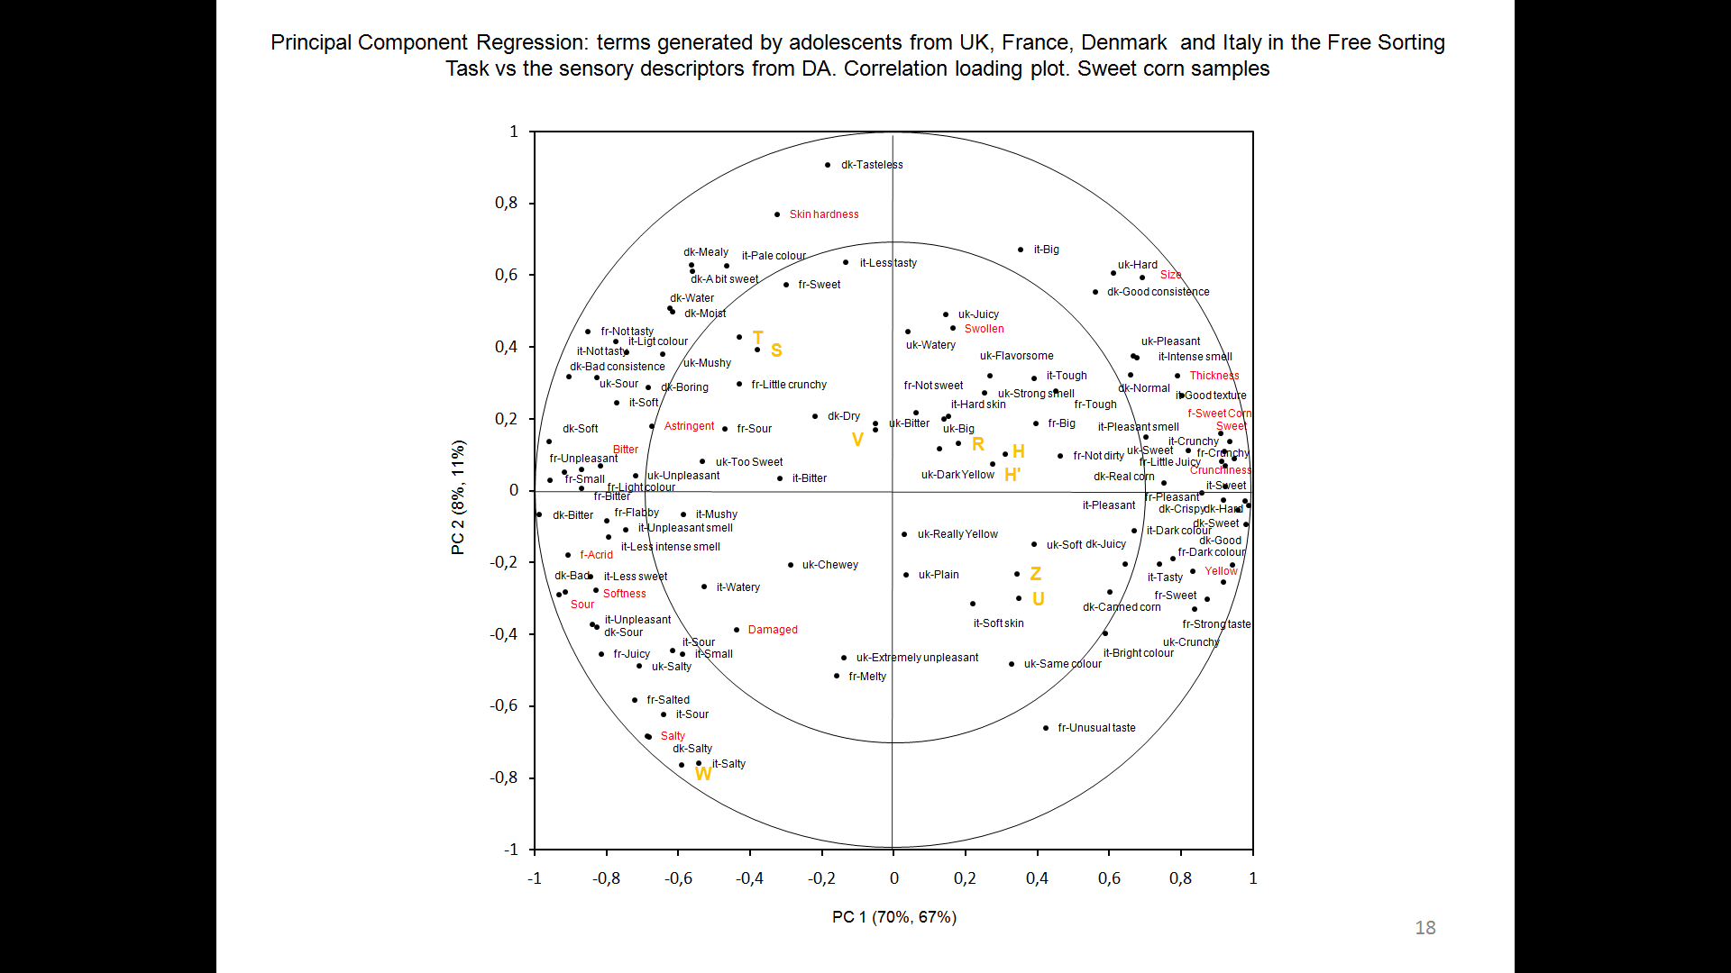

**Figure 19.** Principal Component Regression: terms (in black) generated by adolescents from Italy (it), France (fr), UK (uk) and Denmark (dk) in the sorting task vs the sensory descriptors (in red) from DA. Correlation loading plot. Sweet corn samples. Letters (in yellow) identify the products.

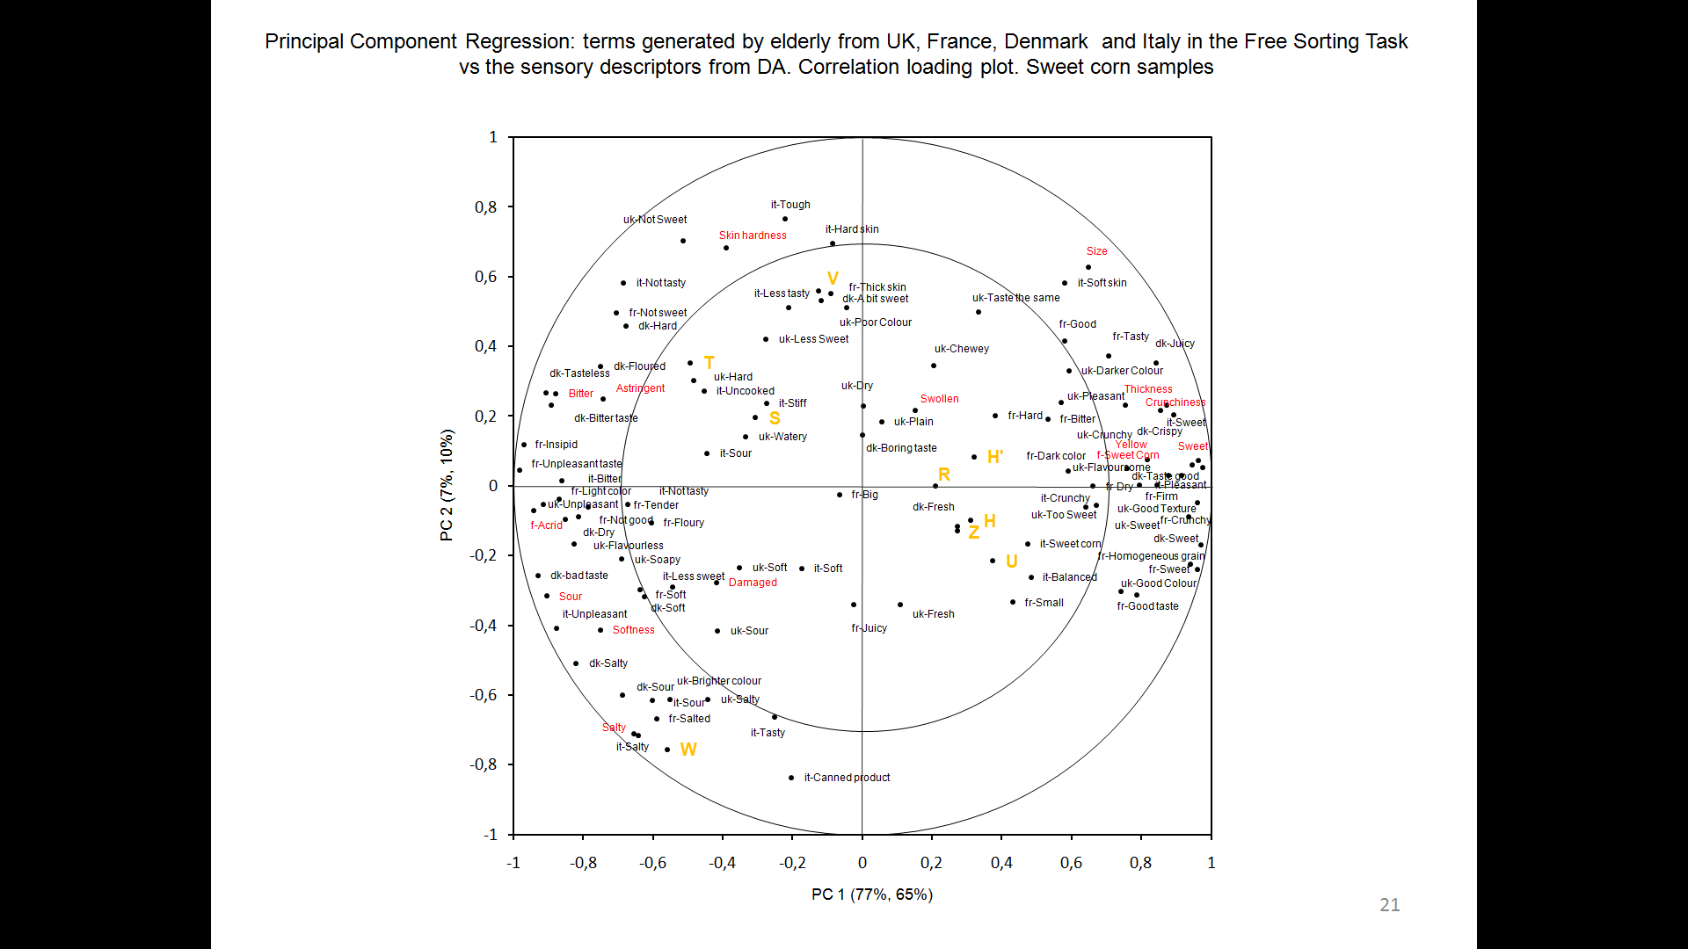

**Figure 20.** Principal Component Regression: terms (in black) generated by elderly from Italy (it), France (fr), UK (uk) and Denmark (dk) in the sorting task vs the sensory descriptors (in red) from DA. Correlation loading plot. Sweet corn samples. Letters (in yellow) identify the products.

*Questionnaire: Familiarity and Stated liking data*

Mean stated liking scores and familiarity rank sums with vegetables names are reported in tables 17 and 18 for adolescents and elderly, respectively. In all countries, the two responses were highly and significantly correlated (adolescents: rDK = 0.98; p≤0.0001; rFR = 0.98; p≤0.0001; rIT = 0.97; p≤0.0001; rUK = 0.97; p≤0.0001; elderly: rDK = 0.91; p≤0.0001; rFR = 0.96; p≤0.0001; rIT = 0.97; p≤0.0001; rUK = 0.94; p≤0.0001). The more the familiarity the higher was the stated liking.

**Table 17.** Familiarity with and Stated Liking (S Liking) for vegetables among adolescents from different countries.

|  |  |  |  |  |  |  |  |  |
| --- | --- | --- | --- | --- | --- | --- | --- | --- |
|  | Denmark (n=88) | | France (n=206) | | Italy (n=110) | | UK (n=93) | |
|  | Familiarity | S Liking | Familiarity | S Liking | Familiarity | S Liking | Familiarity | S Liking |
| Product | Rank Sum | Mean | Rank Sum | Mean | Rank Sum | Mean | Rank Sum | Mean |
| Broccoli | 532bc | 6.14b | 763g | 4.06d | 407f | 3.9f | 661b | 5.9cd |
| Carrots | 731a | 7.44a | 1583ab | 7.39a | 747bc | 7.12ab | 767a | 6.85ab |
| Cauliflower | 383e | 4.91c | 806fg | 4.31d | 359f | 3.69f | 462f | 4.6e |
| Green beans | 396de | 5.02c | 1634a | 7.55a | 733cd | 6.26cd | 468ef | 4.66e |
| Green salad | 775a | 7.33a | 1547ab | 7.37a | 836ab | 6.81bc | 551de | 5.34d |
| Peas | 613b | 6.14b | 1480b | 7.43a | 672cd | 6.31cd | 658bc | 5.47d |
| Spinach | 477cd | 5.94b | 927ef | 5.28c | 662cd | 6.03de | 336g | 3.48f |
| Sweet corn | 613b | 6.5b | 1092cd | 6.24b | 554e | 5.45e | 698ab | 6.91a |
| Tomatoes | 595b | 6.08b | 1574ab | 7.65a | 893a | 7.64a | 571cd | 5.36d |
| Courgettes | 334e | 4.44c | 1002de | 5.09c | 758bc | 6.54bcd | 307g | 3.22f |
| Beans | 360e | 4.76c | 1190c | 6.09b | 642de | 6.06d | 662b | 6.22bc |

*Values followed by different letters are significantly different (p<0.05)*

**Table 18.** Familiarity with and stated liking (S Liking) for vegetables among elderly from different countries.

|  |  |  |  |  |  |  |  |  |
| --- | --- | --- | --- | --- | --- | --- | --- | --- |
|  | Denmark (n=79) | | France (n=196) | | Italy (n=129) | | UK (n=95) | |
|  | Familiarity | S Liking | Familiarity | S Liking | Familiarity | S Liking | Familiarity | S Lliking |
| Products | Rank Sum | Mean | Rank Sum | Mean | Rank Sum | Mean | Rank Sum | Mean |
| Broccoli | 505bcde | 7.18d | 780d | 6.6e | 606e | 6.64f | 654ab | 7.55b |
| Carrots | 666a | 8.37a | 1389a | 8.08bc | 772cd | 7.36e | 724a | 8.18a |
| Cauliflower | 542bc | 8.23ab | 1151bc | 7.95cd | 774cd | 7.56de | 588b | 7.59b |
| Green beans | 429e | 7.37cd | 1444a | 8.36ab | 864bc | 8.23ab | 626b | 8.17a |
| Green salad | 485cde | 7.39cd | 1399a | 8.36ab | 908ab | 8.12ab | 612b | 7.71b |
| Peas | 532bcd | 8.36a | 1240b | 8.2bc | 760cd | 7.84bcd | 616b | 7.79ab |
| Spinach | 460de | 7.79bc | 1038c | 7.66d | 737d | 7.67cde | 371c | 6.22d |
| Sweet corn | 445e | 7.41cd | 728d | 6.53e | 332f | 5.12g | 441c | 7.01c |
| Tomatoes | 577b | 8.04ab | 1470a | 8.55a | 979a | 8.35a | 666ab | 7.9ab |
| Courgettes | 296f | 6.24e | 1217b | 7.65d | 938ab | 8.09abc | 394c | 6.69c |
| Beans. | 280f | 5.64f | 1084c | 7.67d | 848bc | 8.05abc | 580b | 7.68b |

*Values followed by different letters are significantly different (p<0.05)*

Although some similarities are evident, stated liking and familiarity patterns vary across countries in the two ages groups. Carrots are among the most familiar and preferred vegetables by adolescents in all countries. DK, FR and IT adolescent respondents agree on high familiarity with and stated liking for green salad and tomatoes. UK and DK respondents for sweetcorn. Country specific familiarities and stated liking can be observed for peas (DK), courgettes (IT), green beans (FR) and broccoli (UK). French and Italian adolescents are more familiar with and liked more peas than sweet corn. Danish teens do not show differences in either familiarity with or stated liking for peas and sweet corn. British respondents do not show differences in familiarity with peas and sweet corn and liked more sweet corn than peas.

Tomatoes are the most familiar and preferred vegetables by elderly in all countries. Carrots and green beans are the most familiar and preferred in all countries except in IT and in DK, respectively. Country specific familiarities and liking can be observed for broccoli (UK), cauliflower (DK), courgettes and beans (IT). In all countries elderly are more familiar with and liked more peas than sweet corn.

*Actual Liking data*

Mean liking data are reported in tables 19 and 20 for adolescents and elderly, respectively.

**Table 19.** Two-way ANOVA on actual liking data from adolescents: summary table. Mean liking scores by country for pea and sweet corn samples; F and p values.

|  |  |  |  |  |  |  |  |  |  |  |  |  |  |
| --- | --- | --- | --- | --- | --- | --- | --- | --- | --- | --- | --- | --- | --- |
| Country | Pea sample | | | | | | | | | | | F-value | p-value |
| A | B | D | E | F | J | L | O | O' | P | Q |
| Denmark (n=68) | 2.28abc | 2.26abc | 1.99cd | 2.28abc | 2.22abc | 2.06bcd | 2.40ab | 2.57a | 2.51a | 1.75d | 2.31abc | 2.78 | 0.0022 |
| France (n=105) | 5.62d | 5.64d | 5.87cd | 6.76a | 5.00e | 4.04f | 6.15bcd | 6.57ab | 6.45abc | 2.1g | 5.92cd | 38.47 | <0.0001 |
| Italy (n=108) | 4.65cd | 4.11e | 4.24de | 5.25a | 3.38f | 3.19f | 5.56a | 4.74bc | 5.14ab | 1.96g | 4.39cde | 41.42 | <0.0001 |
| UK (n=76) | 3.25abc | 3.24abc | 3.28abc | 3.14bc | 3.38ab | 2.84c | 3.22abc | 3.72a | 3.36abc | 2.00d | 3.37ab | 5.48 | <0.0001 |
| Country | Sweet corn sample | | | | | | | | | | | F-value | p-value |
| H | H' | R | S | T | U | V | W | Z |  |  |
| Denmark (n=86) | 5.64a | 5.85a | 5.56ab | 3.73d | 2.97e | 5.51ab | 4.65c | 2.35f | 5.09bc |  |  | 50.55 | <0.0001 |
| France (n=101) | 5.76ab | 5.74ab | 5.8ab | 4.56c | 4.17cd | 6.01a | 5.25b | 3.84d | 5.21b |  |  | 12.07 | <0.0001 |
| Italy (n=103) | 5.17ab | 5.27a | 5.12ab | 4.03c | 3.54d | 5.1ab | 4.11c | 3.04e | 4.78b |  |  | 21.67 | <0.0001 |
| UK (n=80) | 5.51ab | 5.88a | 4.59def | 4.21f | 4.39ef | 5.36abc | 5.00bcd | 3.16g | 4.90cde |  |  | 14.99 | <0.0001 |

*Values followed by different letters are significantly different (p<0.05)*

It is possible to note that for both canned sample series, no significant differences in mean liking scores were found between replicated samples (H and O for sweet corn and peas, respectively).

Liking ratings expressed by adolescents indicate that, according to F-values, the greatest differences in mean scores among samples were found in France and in Italy. The most liked sample in both countries was sample E while the least liked one was sample P. Mean liking range and F-values were very low both in Denmark and in UK. It seems that these adolescents expressed a generalised disliking for pea samples. Sample P was the most disliked sample in all countries. Mean and F values associated to each country with sweetcorn samples indicate that Danish adolescents discriminate samples in relation to their liking much more than UK, French and Italian teens. On average, adolescents from all countries share the same highest liking for sample H and the lowest for sample W*.*

|  |  |  |  |  |  |  |  |  |  |  |  |  |  |
| --- | --- | --- | --- | --- | --- | --- | --- | --- | --- | --- | --- | --- | --- |
| Country | Pea samples | | | | | | | | |  |  | F-value | p-value |
| A | B | D | E | F | J | L | O | O' | P | Q |
| Denmark (n=54) | 3.93bcd | 3.31ef | 3.78cde | 3.46def | 2.59gh | 2.93fg | 4.52ab | 4.3abc | 4.54a | 2.06h | 3.46def | 13.16 | <0.0001 |
| France (n=98) | 6.18ab | 5.94ab | 6.04ab | 6ab | 4.27c | 3.67d | 6.26a | 6.36a | 6.28a | 2.12e | 5.65b | 42.41 | <0.0001 |
| Italy (n=96) | 5.9bcd | 5.61cde | 5.45de | 5.9bcd | 5.16e | 4.44f | 6.52a | 5.95bc | 6.21ab | 3.22g | 5.52cde | 27.86 | <0.0001 |
| UK (n=75) | 4.81abc | 4.64bc | 5.19ab | 4.37c | 4.23c | 3.54d | 5.25ab | 4.83abc | 5.32a | 2.58e | 4.7abc | 13.14 | <0.0001 |
| Country | Sweet corn samples | | | | | | | | | | | F-value | p-value |
| H | H' | R | S | T | U | V | W | Z |  |  |
| Denmark (n=73) | 6.89a | 6.95a | 6.12bc | 5.07e | 4.14f | 6.73ab | 5.39de | 3.66f | 5.88cd |  |  | 28.65 | <0.0001 |
| France (n=98) | 5.74abc | 6.14ab | 5.9abc | 5.38cde | 4.77e | 6.21a | 5.09de | 4.01f | 5.54bcd |  |  | 9.34 | <0.0001 |
| Italy (n=96) | 5.67bc | 6.03ab | 5.95ab | 5.7bc | 5.34cd | 6.46a | 5.68bc | 4.88d | 5.83bc |  |  | 5.68 | <0.0001 |
| UK (n=80) | 6.21ab | 6.17ab | 5.76bc | 5.44c | 4.56d | 6.46a | 5.44c | 4.18d | 6.3ab |  |  | 13.12 | <0.0001 |

**Table 20.** Two-way ANOVA on liking data from elderly: summary table. Mean liking scores by country for pea sweet corn sample; F and p values.

*Values followed by different letters are significantly different (p<0.05)*

Mean and F values associated to liking scores expressed by elderly for pea samples indicate that French elderly discriminate samples in relation to their liking much more than DK, IT and UK respondents. On average, elderly from all countries share the same highest liking for samples O and L and the lowest for sample P. Regarding sweet corn samples, mean and F values associated to each country indicate that Danish elderly discriminate samples in relation to their liking much more than FR. IT and UK respondents. In general, elderly from all countries share the same highest liking for samples H and U and the lowest for samples T and W.

In order to investigate liking patterns (most liked and most disliked products) in all countries considering individual differences, cross-country preference maps were independently computed for each product for each age group (Fig.21 a-b; Fig.22 a-b).

The maps clearly indicate that adolescents share a common pattern of liking for both peas and corn samples. The first dimension of the pea preference map (Fig.21 a) indicates that liking was oriented towards samples in the right side of the map in opposition to samples located on the left side of the plot (P and J). In fact, most respondents are located in the right of the first component and their liking is mainly driven by *sweet, salty and umami* tastes*, green colour, cooked peas, cooked vegetables* and *onion* flavourattributes, melty and soft texture. *Bitter and sour* tastes*, skin hardness, metallic* and *acrid* flavours mainly drove respondent disliking. It can be noted that in general there are no areas of the map in which subjects from a specific country are concentrated in. This means that differences in liking among samples are driven by the same sensory properties in all countries and that further segmentations for liking are independent from a country effect. Respondents are widely spread along the second dimension. Using the first dimension as cut-off and considering only the subjects in the right of the map, two segments can be identified. Subjects falling in the bottom right of the map prefer samples O and L and their liking is driven, in addition to the attributes correlated to the first dimension listed above, also by *onion* and *cooked peas* and cooked *vegetables* odour notes and “*swollen*” appearance. At same time they dislike samples F, B and P and relate their responses to *bitterness*, *sourness* and *metallic* odour and flavour and *acrid* flavour. Respondents in the top right, show a quite large flexibility in terms of liking, preferring several samples (B, D, A and E) and rejecting samples P and J. Liking and disliking for pea samples of these subjects tend to differ from the rest of the teens mainly in relation to the influence on their responses of appearance attributes. In fact, their liking is positively related to the attribute “*size of seeds*” and “damaged” appearance and negatively driven by the appearance attributes “*size uniformity*” and “*swollen*”.

The internal preference map of figure 21 b shows adolescent individual responses across countries for sweet corn samples. Similarly to what observed in pea preference map, the large majority of respondents are located in one side (right) of the first component indicating a shared general trend in liking patterns among adolescents across countries. The first dimension discriminates samples H, R, U and Z from the rest. Teenagers liking for sweet corn is mainly driven by *sweetness*, *crunchiness*, *yellow colour*, *seed* *size* and *thickness* in opposition to *acrid flavour*, *sour*, *bitter* and *salty* tastes*, astringent, soft texture* attributes. Respondents are spread along the second dimension. However, two segments are identified in the right part of the map using the first dimension as cut-off. Subjects in the bottom right particularly dislike sample T because the *skin hardness*. Teens in the top right dislike sample W and relate their negative hedonic response to saltiness. Thus, the differences between segments are more based on disliking than liking for sweet corn.

Main sensory drivers of adolescent liking for peas and sweet corn samples resulting from the two cross-country internal maps are summarised in Table 21. Sweetness in opposition to sourness and bitterness affects liking for both peas and sweet corn. Saltiness is positively correlated with liking in peas and negatively in sweetcorn as well as softness. Colour intensity is positively correlated with liking in both products. Specific drivers of liking for canned peas are “cooked” flavour notes such as peas, vegetables and onion. Crunchiness, thickness and size of seeds drive liking for sweetcorn.

Elderly tend to share a common pattern of liking for peas samples (Fig.22 a). The first dimension of the pea internal preference map indicates that liking was oriented towards samples in the right side of the map in opposition to samples located on the left side of the plot (P, J and F). In fact, most respondents are located in the right of the first component and their liking is mainly driven by *sweet, salty, softness, umami, green colour, cooked peas, vegetable* and *onion* flavourattributes in opposition to *bitterness, skin hardness, sourness*, *metallic* and *acrid* that mainly drove their disliking. Main differences in liking among samples are driven by the same sensory properties in all countries. Respondents are widely spread along the second dimension. Using the first dimension as cut-off and considering only the subjects in the right of the map, two segments can be identified. Subjects falling in the bottom right of the map prefer samples O, L and Q and their liking is driven, in addition to the attributes correlated to the first dimension listed above, also by *onion* and *cooked peas* and *vegetables* odour notes, “*swollen*” appearance and the “*size uniformity*”. At same time, they dislike samples F and A, and relate their responses to the “*damaged*” appearance and the “*size of the seeds*”. Respondents in the top right prefer several samples (A, B, E and D) and reject samples P and J. These subjects seem to relate their liking to appearance attributes. Their liking is positively related to the attributes “*size of the seeds*”, “*damaged*” and “*uniformity of the colour*” and negatively driven by the appearance attributes “*size uniformity*” and “*swollen*”.

The internal preference map of Figure 22.b shows individual responses from elderly across countries for sweetcorn samples. Similarly to what observed in peas preference map, the most part of respondents are located in one side (right) of the first component indicating a shared general trend in liking patterns among elderly across countries. However, this tendency is less strong of the one observed for pea samples. The first dimension discriminates samples H, R, U and Z from the rest. Liking for sweet corn is positively associated to *sweetness*, *crunchiness*, *intensity of sweet corn flavour*, *yellow colour*, *seed* *size* and *thickness* and negatively to *acrid*, *bitter*, *astringent, sour,* *softness* and *salty* attributes. Using the first dimension as cut-off, in the right part of the map two groups can be identified. Subjects in the top right particularly dislike sample W because of the *softness* and *saltiness*. Elderly in the bottom right dislike samples V and Z because of the *hardness of the skin*. Thus, the differences between segments are more based on disliking than liking for sweet corn.

Sweetness in opposition to sourness and bitterness affects liking for both peas and sweet corn. Saltiness is positively correlated with liking in peas and negatively in sweet corn as well as softness. Colour intensity is positively correlated with liking in both products. Specific drivers of liking for canned peas are “cooked” flavour notes such as peas, vegetables and onion. Crunchiness, thickness and size of seeds drive liking for sweet corn.

Main sensory drivers of adolescent and elderly liking for peas and sweet corn samples resulting from the four cross-country internal maps are summarised in Table 21.

a

b

**Figure 21** (a-b): Internal Preference Map: Correlation loading plot from PCA computed on liking data for peas (a) and sweet corn (b) from DK, FR, IT and UK teenagers. Outer and inner circles on the map represent 100% and 50% explained variance respectively. Geometric forms represent respondents (∆ = FR; ▲= IT; □= UK; ■= DK).

**a**

**b**

**Figure 22** (a-b): Internal Preference Map: Correlation loading plot from PCA computed on liking data for peas (a) and sweet corn (b) from DK, FR, IT and UK elderly. Outer and inner circles on the map represent 100% and 50% explained variance respectively. Geometric forms represent respondents (∆ = FR; ▲= IT; □= UK; ■= DK).

**Table 21.** Main sensory drivers of liking expressed by adolescents and elderly for peas and sweet corn samples.

|  |  |  |  |
| --- | --- | --- | --- |
| Canned Product | Sensory Input | Main Sensory Drivers | |
|  |  | liking | disliking |
| Peas | Appearance | Green intensity |  |
| Flavour | Sweetness  Saltiness  Cooked peas  Cooked vegetables  Cooked onion  Umami* | Sourness  Bitterness  Metallic  Acrid |
| Texture | Softness  Melt in the mouth* | Skin Hardness |
| Sweet corn | Appearance | Yellow intensity  Seed size |  |
| Flavour | Sweetness | Saltiness  Sourness  Bitterness  Acrid  Astringency |
| Texture | Crunchiness  Thickness | Softness |

*\*for elderly only*

**Conclusions**

The activities related to Task 2.1 in WP2 provided a detailed sensory description of canned pea and sweetcorn samples commonly available in the market. Main sensory differences among samples were identified for both products. This information is essential for achieving two aims: exploring sensory characteristics driving elderly and adolescents liking across Europe and studying the relationship between sensory and instrumental data to improve the quality control of these products. Descriptive analysis is an effective methodology to achieve both aims. In the present study DA provided: 1) a validated sensory profile of each sample. 2) the relative importance of appearance, flavour and texture attributes in discriminating products by means of perceptual maps. The study of the relationship between sensory properties and instrumental measurements was then possible. The projection of Firmness and NMR data onto the obtained sensory spaces resulted in a good evidence of the potential use of these measurements to predict relevant sensory differences among samples.

Results from activities related to Task 2.2 show that the minimum number of consumers required for free sorting studies seems higher than the one recommended in previous works in which product configurations were considered stable when working with more than 25-30 consumers (Faye et al. 2006; Blancher et al. 2012). For both adolescent and elderly, a minimum number of 50 subjects is fair when working with familiar canned vegetables such as peas. A larger panel size (70 or more) is required when working with less familiar products such as sweet corn.

However, our results confirmed that product knowledge and in particular one of its components (respondent familiarity with the product under investigation) is a factor that should always be considered to define the panel size to perform a sorting task. When the effect of individual differences in product knowledge needs to be explored a high number of respondents (over than one hundred) is suggested to run a free sort task.

Results from the consumer study (Task 2.3) show that both elderly and adolescent can sort vegetable samples in relation to sensory properties relevant for their hedonic judgment. High correlations values were found in comparing sorting configurations from each country and each age group with the perceptual maps from descriptive analysis for both peas and sweetcorn. Sample grouping was consistent across countries with minor differences that seem to be related to the degree of familiarity with the products. When sorting task is conducted with familiar products (like peas) differences among countries and age groups tend to be minimal. Both elderly and adolescents showed no difficulties in eliciting terms (sensory and hedonic) describing the sample groups they formed in the sorting task. This means that this approach is an effective method to explore vegetable perception in both age groups and obtain information about sensory and hedonic dimensions driving product discrimination. When applied in cross country and across age studies, the free sorting task overcomes limitations of other approaches (e.g. rating methods and questionnaires) in which results might be strongly affected by cultural differences in the expression of results (e.g. differences in the use of rating scale across countries and ages).

Lists of terms of perceived properties of pea and sweetcorn samples were obtained for the two age groups from all countries. This output is relevant when the interest is focused on consumer language in order to better understand sensory barriers to increase vegetable consumption. Relative differences were found in the number and nature of terms used to describe sample groups formed during the sorting task across countries and ages. Appearance seems to be less relevant for elderly than for adolescent in discriminating samples. Old respondents tend to focus their attention more on texture and hedonic terms. The oppositions sweet vs bitter and richness in flavour vs lack of taste, were always associated with hedonic terms and drove product discrimination independently from countries and age groups. The study of the correlation between the occurrences of consumer terms and intensity data from descriptive analysis allowed to “translate” consumer language in sensory characteristics. For instance, the term “bad taste” was found to be associated with sensory attributes like “acrid” or “metallic”. Similarly, the generic negative hedonic expression “bad texture” was found to be associate with the sensory attribute “softness” in sweetcorn samples and “hardness” in pea samples. This information is of great importance to set up proper quality control in food companies.

Task 2.3 explored and compared the liking of adolescents and elderly across the four European countries. Results confirm the effect of familiarity on stated and actual liking for vegetables. The more familiar respondents are with a specific food, the more they will like and prefer it. In the present study the more familiar the respondents were with a vegetable the higher were the differences in liking among the presented samples. For instance, French and Italian adolescents were more familiar with and expressed a higher stated liking for peas than sweet corn. An opposite trend was observed for Danish and British adolescents. As consequence, British and Danish teens scored their liking for sweet corn samples significantly higher than for pea samples.

The analysis of individual differences in liking allowed to understand the role of flavour and texture in canned pea and sweetcorn acceptance from actual tasting experimental sets. The within-product approach used in this study, highlighted that, independently from familiarity and stated liking, main drivers of actual liking and disliking are the same across countries and ages. Sweetness, in opposition to bitterness and sourness, confirmed to drive actual liking for vegetables. The influence of saltiness on liking was positive for peas but negative for sweet corn. Similarly, softness was positively related to liking for peas and negatively for sweet corn. Richness in flavour and in colour was strongly correlated to liking for both peas and sweet corn. This information should be taken into account by food producers and the catering sector when promoting the consumption of peas and sweet corn among adolescents in Europe. In relation to VeggiEAT research project the results of WP2 feeds WP3 Work package 3 where recipe development is underway led by the Institute Paul Bocuse Research Centre.

**References:**

* H. Abdi (2010) Congruence: Congruence coefficient. RV coefficient. and Mantel coefficient . N.J. Salkind.
* Buck. D. (2007) Methods to understand consumer attitudes and motivations in food product developmentt. in Consumer-Led Food Product Development (ed. H.J.H. MacFie). Woodhead Publishing. Cambridge. pp. 141–157.
* Dougherty. D.M. Frey B. (Eds.). Encyclopedia of research designSage. Thousand Oaks. CA . pp. 222–229.
* Faye. P.. Brémaud. D.. Teillet. E.. Courcoux. P.. Giboreau. A.. & Nicod. H. (2006). An alternative to external preference mapping based on consumer perceptive mapping. Food Quality and Preference. 17(7–8). 604–614.
* Heath. P.. Houston-Price. C.. & Kennedy. O. B. (2011). Increasing food familiarity without the tears. A role for visual exposure?. Appetite. 57(3). 832-838.
* Jenkins. S.. & Horner. S. D. (2005). Barriers that influence eating behaviors in adolescents. Journal of Pediatric Nursing. 20(4). 258-267
* Krolner. R.. Rasmussen. M.. Brug. J.. Klepp. K. I.. Wind. M.. & Due. P. (2011). Determinants of fruit and vegetable consumption among children and adolescents: a review of the literature. Part II: qualitative studies. Int J Behav Nutr Phys Act. 8(1). 112.
* [Larson NI](http://www.ncbi.nlm.nih.gov/pubmed/?term=Larson%20NI%5BAuthor%5D&cauthor=true&cauthor_uid=18482818). [Neumark-Sztainer DR](http://www.ncbi.nlm.nih.gov/pubmed/?term=Neumark-Sztainer%20DR%5BAuthor%5D&cauthor=true&cauthor_uid=18482818). [Harnack LJ](http://www.ncbi.nlm.nih.gov/pubmed/?term=Harnack%20LJ%5BAuthor%5D&cauthor=true&cauthor_uid=18482818). [Wall MM](http://www.ncbi.nlm.nih.gov/pubmed/?term=Wall%20MM%5BAuthor%5D&cauthor=true&cauthor_uid=18482818). [Story MT](http://www.ncbi.nlm.nih.gov/pubmed/?term=Story%20MT%5BAuthor%5D&cauthor=true&cauthor_uid=18482818). [Eisenberg ME](http://www.ncbi.nlm.nih.gov/pubmed/?term=Eisenberg%20ME%5BAuthor%5D&cauthor=true&cauthor_uid=18482818). (2008). [Fruit and vegetable intake correlates during the transition to young adulthood.](http://www.ncbi.nlm.nih.gov/pubmed/18482818) Am J Prev Med. 35(1):33-37.
* Lawless. H.T.. Sheng. N. & Knoops. S.S.C.P. (1995). Multidimensional scaling of sorting data applied to cheese perception. Food Quality and Preference. 6. 91–98.
* Lawless. H. T.. & Heymann. H. (2010). Sensory evaluation of food. Principles and practices. (2nd edition). New York: Springer.
* Martens H and Martens M (2001). *Multivariate analysis of quality: an introduction*. Chichester. John Wiley & Sons Ltd.
* Mela. D. J. (2006). Eating for pleasure or just wanting to eat? Reconsidering sensory hedonic responses as a driver of obesity. *Appetite* 47. 10–17.
* Monteleone. E.. Frewer. L. Wakeling. I.. Mela D. (1998). Individual differences in starchy food consumption: the application of preference mapping. *Food Quality and Preference*. vol. 9. pp. 211-219.
* Morizet. D.. Depezay. L.. Masse. P.. Combris. P.. Giboreau. A.. (2011). Perceptual and lexical knowledge of vegetables in preadolescent children. *Appetite* 57. 142–147.
* Murray JM. Delahunty CM and Baxter IA (2001). “Descriptive sensory analysis: past. present and future”. *Food Research International*. 34. 461–471.
* Naes T. Brockhoff PB and Tomic O (2010). *Statistics for sensory and consumer science*. Chichester. John Wiley & Sons. Ltd.
* Pelt J. M. (1993). Des légumes. Ed. J’ai Lu. Bien être. Coll Nature
* Piggott JR and Watson MPA. 1992. Comparison of free-choice profiling and the repertory grid method in the flavor profiling of cider. J Sens Stud 7(2):133–45 .
* Piggott JR. Simpson SJ and Williams SAR (1998). “Sensory analysis”. *International Journal of Food Science and Technology*. 33. 7–18.
* Valentin. D. . Chollet. S. Lelievre. M. & Abdi. H. (2012) Quick and dirty but still pretty good: a review of new descriptive methods in food science. International Journal of Food Science and Technology. 47. 1563–1578
* Varela. P. and G. Ares. Sensory profiling. the blurred line between sensory and consumer science. A review of novel methods for product characterization. Food Res Int. 2012. 48: p. 893-908
* Vidal. L.. Cadenaa.R.S.. Antúneza. L.. Giméneza. A..Varela. P.. Ares G. (2013). Stability of sample configurations from projective mapping: How many consumers are necessary? Food Quality and Preference Volume 34. Pages 79–87.