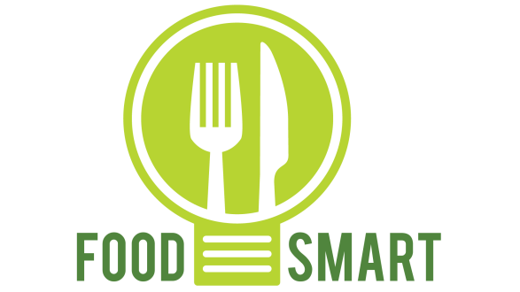

Marie Skłodowska-Curie Actions (MSCA)
Research and Innovation Staff Exchange (RISE)
H2020-MSCA-RISE-2014
Grant agreement no: 643999

Work Package 7
Project Dissemination Activities

Identification number in the dissemination plan | Activity | Type | Date | Targeted audience/n. of people reached |  |  | Responsible organisation/person
 |  |  |  | Scientific Community  Researchers/Higher Education | Industry | General Public
PUBLICATIONS
1 | Price S, Hartwell H, Hemmingway A, Chapleo C. (2016). Workplace foodservice; perception of quality and trust. Appetite. 97:169-175 | Publication | 2016 | 5,000 |  |  | Bournemouth University
2 | Price et al. (2016). What are we eating? Consumer information requirement within a workplace canteen. Food Quality and Preference. 53: 39-46 | Publication | 2016 | 5,000 |  |  | Bournemouth University/all partners
3 | Price, S., Bray, J. P., & Brown, L. (2017). Enabling healthy food choices in the workplace: the canteen operators’ perspective. International Journal of Workplace Health Management, Vol. 10 Issue: 4, pp.318-331, https://doi.org/10.1108/IJWHM-12-2016-0087 | Publication | 2017 | 3500 |  |  | Bournemouth University
4 | Xiao Zhou, F. J. Armando Perez-Cueto *, Quenia Santos, Erminio Monteleone, Agnès Giboreau, Katherine Appleton, Thomas Bjørner, Wender Bredie, Heather Hartwell (2018) A systematic review of behavioural interventions promoting healthy eating among elderly people. Special issue Nutrition and Ageing Nutrients 2018, 10(2), 128 http://www.mdpi.com/journal/nutrients/special_issues/nutrition_ageing  https://doi.org/10.3390/nu10020128  http://www.mdpi.com/2072-6643/10/2/128 | Submitted: 5 October 2017; Manuscript ID: nutrients-235540 - Accepted for Publication 24 Jan 2018  Open access | 2018 | Open access |  |  | University of Copenhagen/all partners
5 | Bray, J. and Hartwell, H. 2018. How to stop your lunch break damaging your health. METRO 28th February 2018. https://www.metro.news/how-to-stop-your-lunch-break-damaging-your-health/957042/ | Online publication | 2018 |  |  | 1.3 million | Bournemouth University
6 | CORDIS (the European Commission's primary service for EU-funded research results) published an article about the results of our project FoodSMART.  The article was included in the Results Pack on 'Food Systems Transformation', based on a request from DG RTD.  We are pleased to inform you that the Results in Brief article you recently collaborated with us on for our Results Pack on Food Systems has been published on the CORDIS website in six languages at: https://cordis.europa.eu/result/rcn/229077_en.html  The full Results Pack can be found here: https://cordis.europa.eu/article/id/400948-food-2030-innovative-eu-research-ensures-food-system-is-future-ready_en.html | Online publication | June 2018 | Open access |  |  | EC/All partners
CONFERENCES
 | ICCAS 2015 “Criteria of importance influencing food choice in workplace canteens” | Participation to a conference | 2015 | 100 | 20 |  | Bournemouth University
 | IPB PhD. Summer school (FoodSMART) “Criteria of importance influencing food choice in workplace canteens.” | Organisation of a conference | 2015 | 30 | 20 |  | Organised by IPB  BU presented
 | International colloquium on food choice interventions, University of Copenhagen “The role of choice architecture in public health nutrition and the rationale for uCare” | Choose an item. | 2015 |  |  |  | Copenhagen University
 | The Behavioral Economic Research Group, University of Copenhagen “FoodSMART Presentation at the Food and Resource Economics Department, University of Copenhagen” | Choose an item. | 2016 |  |  |  | Copenhagen University
 | CAUTHE 2016 “FoodSMART-shaping smarter consumer behaviour and food choice” | Participation to a conference | 2016 | 100 | 20 |  | Bournemouth University
 | 9th International Symposium - Social and Cross-cultural Factors of Culinary and Eating Behaviors Symposium at the Institut Paul Bocuse “FoodSMART – results from WP2” | Organisation of a conference | 2016 | 30 | 20 |  | Organised by IPB  BU presented
 | EuroCHRIE 2016 " FoodSMART – a tool for wellbeing?” | Participation to a workshop | 2016 | 100 | 20 |  | Bournemouth University
 | Nutrition Society: Poster - “Important information for the selection of workplace canteen meals: A consumer segmentation study” | Participation to a conference | 2016 | 100 |  |  | Bournemouth University
 | Saulais L. (2016) “Behavioral Economics: What does it have to do with what I order?” , ENABLE Cluster Workshop “FOOD 2030 - Die Zukunft der Ernährung im Zeitalter der Konnektivität“, Technische Universität München, Garching, Germany. December 1st, 2016 | Participation to a conference | 2016 |  |  |  | IPB
 | Saulais, L., Choice architecture for the promotion of health and sustainability: ethical concerns in foodservice, Online Symposium on Ethics in Foodservice, Food Decisions Research Laboratory and Rock Ethics Institute, Penn State University, 9 December 2016 | Participation to a conference | 2016 | 50 |  |  | IPB
 | International Symposium - Food Choice environments to promote healthy and sustainable eating behaviours Nudges in perspective: “Healthy and sustainable eating in foodservice environments : challenges and perspectives “ | Participation to a conference | 2017 | 30 | 20 |  | Bournemouth University Organised by IPB
 | International Symposium - Food Choice environments to promote healthy and sustainable eating behaviours Nudges in perspective: “Living lab experiments as a tool to investigate food choice biases and interventions”, | Organisation of a conference | 2017 | 30 | 20 |  | Organised by IPB
 | ICCAS 2017: “Critical evaluation of the current and future role of technology in eating out food choice” | Participation to a conference | 2017 | 100 | 20 |  | Bournemouth University
 | Industrial Catering – yearly based conference | Participation to a conference | April 2017 |  | 70 |  | Ronge & Partner
 | Food Service Europe – yearly based conference | Participation to a conference | May 2017 |  | 70 |  | Ronge & Partner
 | International Tourism and Hospitality Conference Visitor Economy: Strategies and Innovations Bournemouth University “FoodSMART: Think Smart, Eat Smarter” | Participation to a conference | 2017 | 100 | 20 |  | Bournemouth University
 | Saulais L. (2017) HEALTH ON THE MENU: BEYOND CALORIE INFORMATION. 3rd Online Interdisciplinary Research Symposium in Foodservice Decisions. « Understanding Foodservice Decisions ». December 1st, 2017. Penn State University – College of Health and Human Development | Participation to a conference | 2017 |  |  |  | IPB
 | Saulais L. (2017) Investigating food decisions: what can we learn from living lab experiments? nutriCARD – Lecture in Kooperation mit dem Institutskolloquium des Instituts für Ernährungswissenschaften, Kompetenzcluster für Ernährung und kardiovaskuläre Gesundheit, Institut für Ernährungswissenschaften (Hörsaal), Friedrich-Schiller-Universität Jena, Germany, June 28th, 2017 | Participation to a conference | 2017 |  |  |  | IPB
 | CHME 2018, Bournemouth www.bournemouth.ac.uk/CHME | Participation to a conference | 22-25 May  2018 | 100 | 20 |  | Bournemouth University
 | International Food Marketing Research Symposium 2018, June 13-14, 2018  http://institutefpm.com/wp/event-information-2/registration-payment/# | Paper at the conference | June 13-14, 2018 | 100 | 20 |  | Bournemouth University
 | International Symposium – “EATING AT WORK” http://research.institutpaulbocuse.com/en/events/eating-at-work-8784.kjsp | Organisation and participation to a conference | 20 September 2018 | 30 | 30 |  | Organised by IPB
 | Vietnam UK Higher Education Forum, Hanoi http://www.vneconomictimes.com/article/society/vietnam-uk-higher-education-forum-held Presentation reflecting on cross-national research collaboration on EU project FoodSMART (grant 643999) | Speaker at the Forum | 30 October 2018 | 100 |  |  | Dr Jeff Bray
 | ICCAS 2019, Wales | Participation to a conference | Forthcoming  2019 | 100 | 20 |  | Bournemouth University
STUDENT DISSERTATION
 | Sarah Price | PhD thesis | 2017 completed | N/A |  |  | Bournemouth University
 | Natasha Pringle. Bachelor dissertation | Choose an item. | Forthcoming 2018 | N/A |  |  | Bournemouth University
EVENTS (WORKSHOPS&SEMINARS)
 | BU Festival of Learning “FoodSMART – Eat out smarter!” | Participation to an event other than a conference/workshop | 2016 | 30 | 30 | 30 | Bournemouth University
 | FoodBIZ | Organisation of a workshop | 2016 | 30 | 30 |  | Bournemouth University
 | Global Festival of Learning, Malaysia “FoodSMART – Eat out smarter!” | Participation to an event other than a conference/workshop | 2016 | 70 | 15 |  | Bournemouth University
 | BU impact workshop “FoodSMART impact” | Participation to a workshop | 2016 | 40 |  |  | Bournemouth University
 | ESRC Festival of Social Sciences “Innovations in Hospitality and Travel” | Participation to an event other than a conference/workshop | 2016 | 90 |  |  | Bournemouth University
 | Tourism and Hospitality @ BU “Food Innovation & Competitiveness” | Training | 2016 | 50 |  |  | Bournemouth University
 | Food Matters Live: “Understanding environmental factors influencing food choice in the foodservice industry », Tackling Obesity Seminar | Participation to an industry conference | 2016 | 5,000 |  |  | IPB
 | Saulais, L., Comment sensibiliser les convives et les parents au bien-manger et faire évoluer les comportements alimentaires ? , Journée d’étude organisée par Acteurs de La Vie Scolaire : Restauration Collective : quelle stratégie pour allier circuits courts, bio et lutte contre le gaspillage , 8 décembre 2016, Paris Pas de NDF | Participation to a workshop | 2016 | 50 |  |  | IPB
 | 14:Live “FoodSMART – Eat Out Smarter! Have you ever considered what’s in your food when you’re eating out?” | Participation to an event other than a conference/workshop | 2017 | 20 |  |  | Bournemouth University
 | Project featured on the Danish Ministry of Higher Education and Science - Webinar – How to write a successful proposal for MSCA-RISE | Training | 2017 |  |  |  | Copenhagen University
 | Global Festival of Learning, China “FoodSMART: Think Smart, Eat Smarter” | Participation to an event other than a conference/workshop | 2017 | 100 |  |  | Bournemouth University
 | Training course “Diplomierter Großküchenleiter”: Time Frame from March – July 2017. One block of the course is about digitalization and thus the app FoodSMART is part of the training course theme. | Training course | March – July 2017 |  | 100 |  | Ronge & Partner
 | Marie Curie Ambassador day | Choose an item. | 2017 |  |  | 30 | Bournemouth University
 | Experimental Café: FoodSMART APP test | Choose an item. | 2017 | 30 |  |  | Bournemouth University
 | Fair Salzburg 2017 “Alles für den Gast” – the biggest gastronomy fair in middle Europe | Keynote Speaker at the opening | 11/11/2017 |  | x | x | Ronge & Partner
 | Keynote speaker at Genussgipfel (Presentation of the FoodSMART Project) | Participation to a conference | 29/11/2017 |  | 50 | x | Ronge & Partner
 | « Alimentation, Bien-être Et Santé – Perspectives Comportementales » Séminaire THERMOTEL – Ecully, 11 mai 2017 | Participation to a professional workshop | 2017 |  |  |  | IPB
 | Living Labs: a tool for innovation in the public and private sector? The Institut Paul Bocuse experience. Introduction lecture of the RICHFIELDS Plenary Project Meeting, 6-8 November 2017 Lyon, France | Keynote lecture at a scientific workshop | 2017 |  |  |  | IPB
 | Industry Day, London | Organisation of the event – participants BU students and Industry | 2 Feb 2018 | 90 | 30 |  | Bournemouth University
 | FoodSMART App promotion talk Mar 2018 https://microsites.bournemouth.ac.uk/alumni/2018/03/29/alumnus-supports-smarter-eating-app-project/ | Industry talk | 28 Mar 2018 |  | 10 |  | Bournemouth University
 | Global Festival of Learning, Germany 16-19 April 2018  FoodSMART: Think smart, eat smarter. Presenting project and app to a range of German academic and practitioner audience | Organisation and Presentation | 2018 | 100 |  |  | Bournemouth University
 | Pint of Science talk. Think smart, eat smarter. Presenting project and app to public. 14th May 2018 https://pintofscience.co.uk/organisation/bournemouth  https://pintofscience.co.uk/event/being-fit-and-healthy-ageing | Public talk | 2018 |  |  | 30 | Bournemouth University
 | “Panepistimiaka Nea” - presentation in Greek of the FoodSMART project , also published in the University News in September 2018 | Presentation and internal university publication | Sep 2018 |  |  |  | University of Macedonia
 | Adriana Galiñanes Plaza - Contextual methodologies in sensory and consumer studies. 10th October 2018. Presentation at the Research Seminar of the Design and Consumer Behavior department at the KU. | Seminar | October 2018 | x |  |  | IPB
 | Adriana Galiñanes Plaza – How context influences consumers’ behavior. 11th October 2018. Presentation to the master’ students of Food Innovation and Health at the KU. | Seminar | October 2018 | x |  |  | IPB
SOCIAL MEDIA & NEWS
 | Project website  www.foodsmartproject.com | Website | 2015-2019 |  |  |  | Bournemouth University/all partners
 | Twitter account @EU_foodsmart  DECEMBER 2018 ANALYTICS:  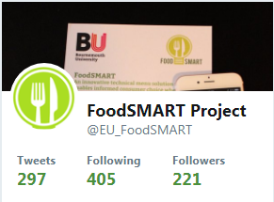  SEPTEMBER 2018 ANALYTICS:  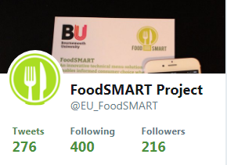  MAY 2017 ANALYTICS: 8 tweets; 3,933 impressions; 241 profile visits; 9 mentions; 5 new followers;  APRIL 2017 ANALYTICS: 1 tweets; 1,333 impressions; 57 profile visits; 1 mentions; 8 new followers; | Social Media | 2015-2019 |  |  | 3097 | Bournemouth University/all partners
 | Youtube account FoodSMART Youtube Channel  ANALYTICS  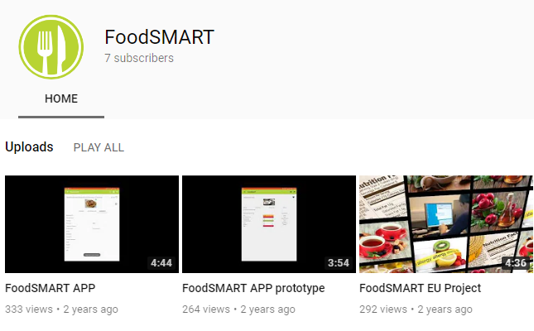  WATCH TIME: 8 MINUTES; TOP VIDEO: “FoodSMART APP prototype” with 319 views; TOP COUNTRIES: UK, South Africa, Belgium, Iraqi and Greece | Video/Film | 2015-2019 |  |  | 889 | Bournemouth University/all partners
 | - FoodSMART EU Project | Video/Film | 2015 |  |  |  | Ronge & Partner
 | - FoodSMART APP prototype | Video/Film | 2016 |  |  |  | Bournemouth University
 | - FoodSMART APP | Video/Film | 2016 |  |  |  | Bournemouth University
 | News - Developing an app for smart food choices | Press release | 2015 |  |  |  | Copenhagen University
 | News - Mobilen skal informere on fodevarer | Press release | 2015 |  |  |  | Copenhagen University
 | Research Photography Competition – FoodSMART Project  Click here to see the picture | Participation to an event other than a conference/workshop | 2016 |  |  |  | Bournemouth University
 | Project newsletter, mailing list distribution/subscription | Communication Campaign | 2016-2019 |  |  |  | Bournemouth University
 | The Conversation: “How to stop your lunch break damaging your health”  http://theconversation.com/how-to-stop-your-lunch-break-damaging-your-health-72694  ANALYTICS: 2,872 reads. 25 Likes on Twitter, 40 on Facebook, 217 on LinkedIn. 2 comments and 3 publishers. Popular in the UK, Australia, USA, Canada and France. | Non-Scientific and non-perr reviwed publication | 2017 |  |  | 2,872 | Bournemouth University
 | Research Gate: https://www.researchgate.net/project/FoodSMART | Social Media | 2017-2019 |  |  |  | Bournemouth University/all partners
 | Google Play – FoodSMART APP | Choose an item. | 2017 |  |  |  | University of Macedonia/ all partners
 | National Italian TV station RAIUNO. SUPERQUARK, a primetime nature, science, medicine, technology, and archaeology Italian TV program presented by Piero Angela, which has been broadcast with continuing success on RAIUNO for twenty years now, is considering to prepare a reportage on HEALTH APPS | Italian TV | 2018
FOLLOW ON FUNDING
 | Higher Education Innovation Fund (HEIF) £ 60.000 | Choose an item. | 2015-2016 | N/A |  |  | Bournemouth University
 | PhD. Scholarship (Sarah Price) | Choose an item. | 2016 | N/A |  |  | Bournemouth University
 | Sawtooh Software (Sarah Price) | Choose an item. | 2015-2016 | N/A |  |  | Bournemouth University

