How to Create a Padlet

Padlet is an online discussion tool, an electronic whiteboard or flipchart, in which students can post their ideas on a certain subject and view other students’ posts. Padlet also allows students to post links, photos, videos, songs, documents, and even other Padlets.

1. Access Padlet at the following web address: www.padlet.com

2. Click “sign up.”

3. Enter your email and create a password. Click “sign up”.
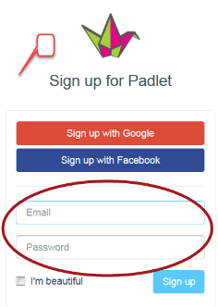

4. Type your name and create a username. Click “save and continue”.
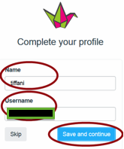
You will be asked if you would like to add superpowers to your account. Click “skip” at the top.
5. To create a new Padlet, click on “New Padlet.”
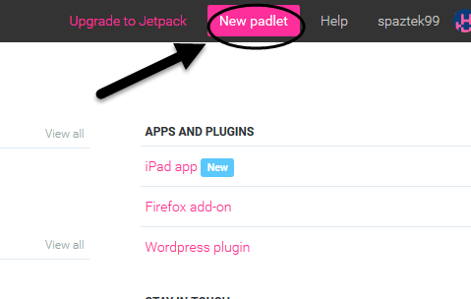
6. Your screen now invites you to add a title and description. [Here is a good place for you to repeat the instructions you have provided for your students. You might also remind them that they must put their names on their posts if you want to award any marks for posts (maybe last name and first initial, if they are worried about privacy), and everything they post is public.] You can choose a layout for posts. Also, you can choose wallpaper. You can also upload wallpaper from your personal images.

Note: This “Modify Padlet” screen is handy. If you lose it and need it back at any point, click the settings cog button at the top right:
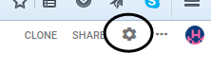
7. In order for your students to be able to post on Padlet, under “Share” “choose “People and Privacy.”
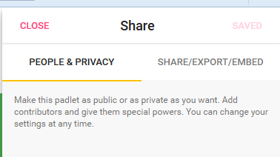

Choose “Public” and “Can write.” Leave everything else alone unless you wish to moderate comments. Then click “Next” at the top right.
Click on “Start Posting” to close that screen and find your link.
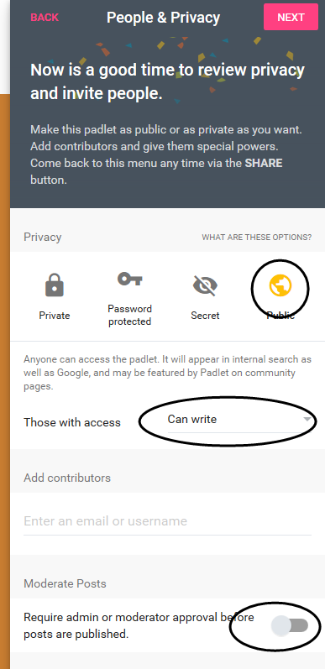

8. On the right hand, top side, click on “share.”

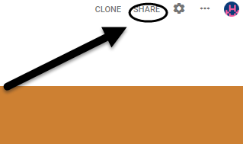

9. Next to “People and Privacy” you will see “Share/Export/Embed.” Click on that.
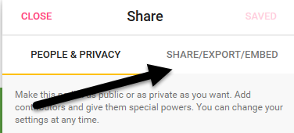

10. There are two things you probably want for exporting your Padlet into Brightspace. They are “Copy link to this padlet” or “Embed in your blog or your website.” At this point, you are ready to put your Padlet into Brightspace.
Putting Padlet in Brightspace

After you have made a Padlet, you have two options to put your Padlet on Brightspace.
To start, open another browser tab and go to Brightspace and go into the course you want your Padlet in.

You’ll want to work with two browser tabs open, one for your Brightspace unit and the other with your Padlet. You will switch back and forth between the two.

One way to put Padlet in your course is to simply add a link to it.

a. In your course, click “Content”.

b. Click on the module you want the Padlet link to go into under “Table of Contents,” then click “Upload/Create.”

c. Click “Create a Link.”

d. Switch over to the browser tab with the Padlet on it. Click “Share” on the top right corner. Then, click “Share/Export/Embed.” On that screen, choose “Copy link to this Padlet.” When you click that line, you will see a note pop up that says, “Copied link to Padlet to your clipboard.”

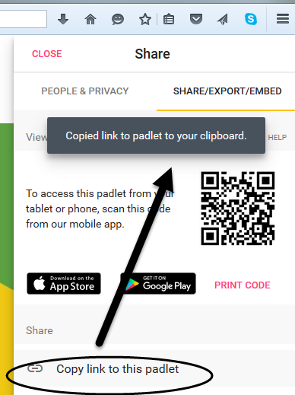

e. Switch back over to the Brightspace tab, and right click and paste in the URL box. You can also click in the URL box and choose “CTRL+V” (Command+V on Macs).
f. Give your link a title (what your students will see when they click the link), for best results choose “Open as External Resource,” then click “Create.”

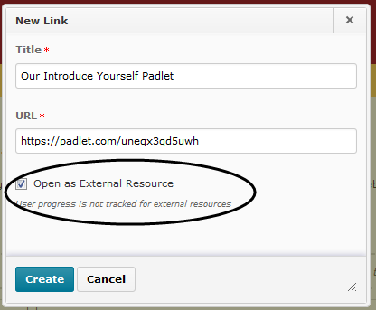

g. Congratulations! Your link is created, and your students have a link to your Padlet!

The other way to put a Padlet into Brightspace is to embed it, so students can see the Padlet content immediately, without having to exit their Brightspace screen.

a. Go into your Brightspace unit and click “Content.”

b. Click on the module you want the Padlet link to go into under “Table of Contents,” then click “Upload/Create” and “Create a File.”

c. Give your file a title in the space provided. Also, in the box, provide the instructions for the activity if this is the first time students have used Padlet.

d. Switch back over to the browser tab with the Padlet on it. Click “Embed in your blog or website.” An embed code will appear. Click “Copy” underneath it.

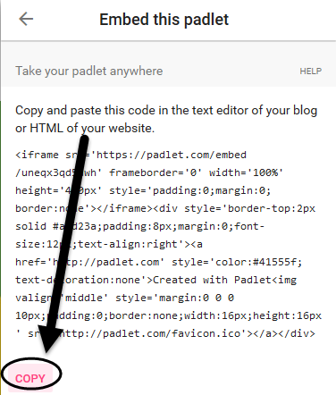

e. Tab back to Brightspace and click the “Insert Stuff” icon (top left)

f. Click “Enter embed code.”

g. In the box provided, right click and paste, or click and choose “CTRL+V” (Command+V on a Mac).

h. Your code will paste. Choose “Next” at the bottom. Then, make sure the button “Always trust this URL” is checked, and click “Allow.” Then click the blue “Insert” button at the bottom.

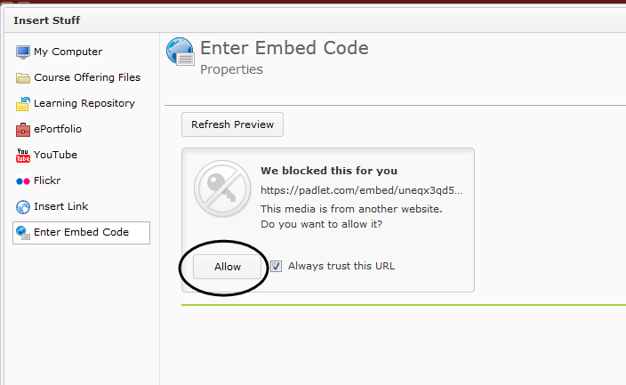

j. Your Padlet will appear on the Brightspace page.
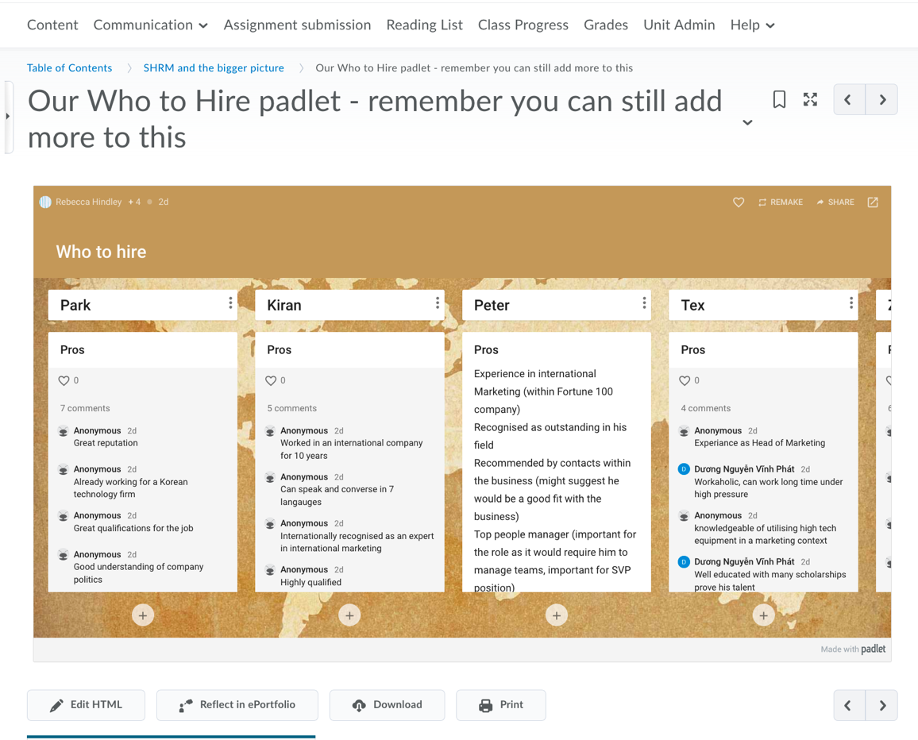

If you are planning to give the URL to student to access the page without embedding it into Brightspace, then it’s a good idea to edit the URL that Padlet automatically allocates to something a bit more meaningful, and easier for students to type.

