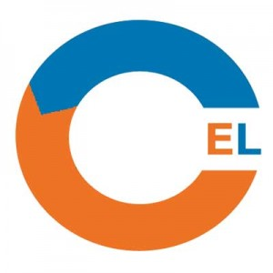
CEL/SUBU Undergraduate Co-creation awards 2019: Application Form.
NB: To be completed by the student/s.

- Name of student/s

- Programme of study, level of study (eg Level 4, 5, or 6)including name of Faculty

3. Name of member of staff who will be working with you on the co-creation project

- Title of project

- Description of how the project aims to achieve co-creation(maximum 500 words)

- Expected outcomes

- Dissemination plan (this must include a CEL blog post)

Please submit by email to aquinney@bournemouth.ac.uk by Monday 15th April 2019

