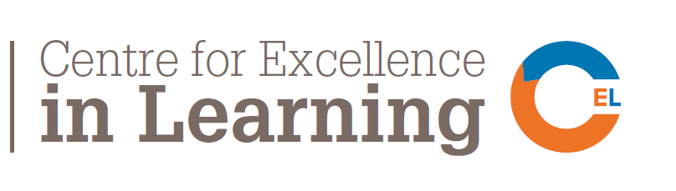

STUDENT/STAFF CO-CREATION PROJECTS-
A CALL FOR BIDS FROM FINAL YEAR UNDERGRADUATE STUDENTS
Deadline: Friday 17th November 2017, 5pm
Submissions to: Dr Marcellus Mbah (mmbah@bournemouth.ac.uk)

Aim: This project aims to support the development of student led, collaborative projects, leading to co-created outputs such as a jointly authored research paper, conference presentation or an artefact. These may be part of the curriculum (unit assessment driven for example) or co-curricular (related to the programme but not to a particular unit assessment/expectation). It is open to final year undergraduate students in the first instance.
Process: Interested students will identify a topic of relevance and an academic they would like to work with on a project that will be delivered in semester two of 2017/18. A brief project plan with intended outcomes (see proforma overleaf) will be submitted to a panel organised by the Centre for Excellence in Learning for review and a significant number of entries which meet the criteria most effectively will be awarded £500 each. The funding can cover consumables, travel or other sundries that will facilitate success.
TIMESCALE
Date | Activity
Monday 23rd October 2017 | SUBU & CEL launch call
Tuesday 24th Oct – 10th Nov 2017 | Drop in sessions in case you have any question  24th Oct. 11:30 – 1pm: BOHO lounge, Bournemouth House  25th Oct. 2:30 – 4:30pm: PG30a Poole House, Talbot  27th Oct. 9:00 – 10:30am: PG30a Poole House, Talbot  31st Oct. 11:30 – 1pm: BOHO lounge, Bournemouth House  01st Nov. 2:30 – 4:30pm: PG30a Poole House, Talbot  03rd Nov. 9:00 – 10:30am: PG30a Poole House, Talbot  07th Nov. 11:30 – 1pm: BOHO lounge, Bournemouth House  08th Nov. 2:30 – 4:30pm: PG30a Poole House, Talbot  10th Nov. 9:00 – 10:30am: PG30a Poole House, Talbot
Friday 17th November 2017 | 5pm deadline for entries
Tuesday 28 November 2017 | Panel meets to review bids
Tuesday 5th December 2017 | Awards Ceremony
Thursday 31st May 2018 | Project reports to include one image and a 300 word blogpost submitted

CRITERIA
- The project brings together a student and academic to work collaboratively
- The project is delivered within 4 months
- The project will lead to specific outputs e.g. publication, presentation, product
- A short report on the outputs will be submitted to the programme leader on completion of the project.

STUDENT/STAFF CO-CREATION PROJECTS- BIDDING FORM
DETAILS

- Name of student(s)

- Course of study

- Name of member of staff who will be partnering with you

- Title of project

- Planned timescale

- Description of how co-creation will be achieved (maximum 500 words)

- Expected outcomes

Please submit electronically to Dr Marcellus Mbah at ‘mmbah@bournemouth.ac.uk’ by 5pm Friday 17th November, 2017.

