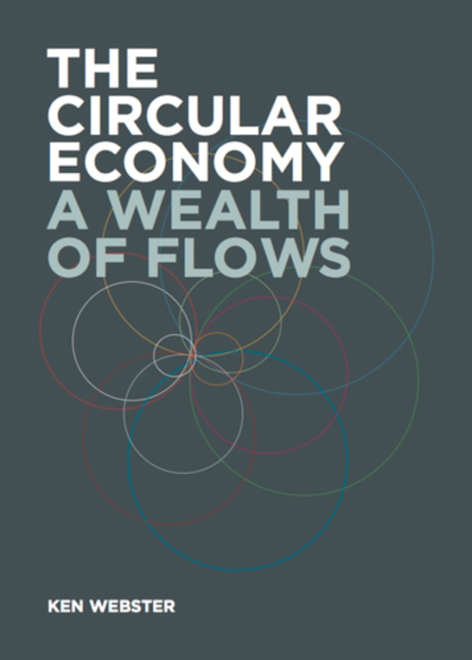
Studying together – through participative Peer to Peer learning – Ken Webster’s new book:
‘The Circular Economy; A Wealth of Flows’
Ken is Head of Innovation at the Ellen MacArthur Foundation.
‘The Circular Economy – A wealth of Flows’ elaborates on the fundamental ideas that structure the Circular Economy and helps define the concept of a regenerative model – able to decouple growth from the consumption of the earth’s finite resources:
”Ken’s understanding of framing and his ability to consistently refer to the ‘big picture’ provides a comprehensive narrative. The Circular Economy gives us the opportunity to build a system that can run in the long term.”
Ellen MacArthur

Adapting in response to feedback is key to systems thinking. Through evolving our consciousness this decade can become in Ken’s words, “the gateway to a Circular Economy”.

The key to complexity is systems thinking
The key to systems thinking is patterns
The key to patterns is to form them into a language
The Group will draw from Ken’s work that shows the big picture/macrocosm, co-creating relationships in how to “accelerate the transition to a Circular Economy” through Systems Thinking – Nature as Model, Mentor and Measure. Ken Webster, author, will join us in our final session.
We will connect the patterns already living in us in more depth to the Circular Economy and create our own unique relationship. Let’s form the language.

HOW?
Through a learning method that addresses the whole of us (imaginative thoughts; feelings/ existing patterns and relationships within each of us uniquely; and actions or intentions), not just a part – the intellect alone.
We begin by stimulating our collective imaginations through peer to peer learning, creating pictures together of the text we read from ‘A Wealth of Flows’.
Having built the facts together, we then create our own connections, encouraging our own unique patters and relationships to appear by identifying them. After these connections have been made we can define our own meaning through stating our Intentions and wish to Act. Meaning that is Self–defined comes through deep learning.
Critique is welcome during each study group; in written feedback at the end of each session, and, Ken will join us in our final session, to receive your critique of his book, personally. Feedback is at the heart of systems thinking!
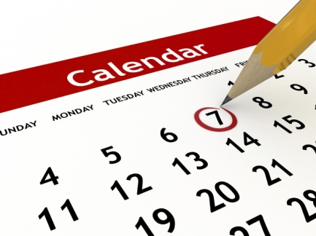
WHEN?
The next session is on 27th January 18:30-20:30.
Then at the end of the month until the Spring.
Each session is stand-alone – come to as few or as many as you wish so new participants are always welcome.
Reserve your place here:
http://circular-economy-study-group2.eventbrite.com

WHERE?
Venue: Bournemouth University Business Centre - room TBC
WHO?
This study group is for those of us who are part of this paradigm shift, or wish to be.
Taking as our starting point “Why a Circular Economy WILL work” – we will connect the big picture to our own already existing, individual and unique patterns and relationships.
Welcome to all businesses; educators; inspired lay people and anyone who wishes to be part of the paradigm shift from a linear economy (take – use – waste), through sustainability (doing less harm), to a circular economy - decoupling of growth from finite resources. Where waste = food (cradle to cradle).

CORE GROUP
Janette Scott-Tams Relationship - to Your Self & Your World
Patrick Andrews New Forest Advisory. Poet and founder of Human Organising Project.
Gwyn Jones Director Association of Sustainability Practitioners

